**OpenStudio 1.11 - Basic Workflow Exercise Instructions**Updated April 27, 2016

**Table of Contents**

Section 1 - Model the Building Envelope 1

Section 2 - Customize the Envelope, Fenestration, and Add Site Shading. 4

Section 3 - Assign Building Activity and Thermal Zones 7

Section 4 - Basic Simulation Run in OpenStudio Application 9

Section 5 - Adjust Internal Load and Default Construction Values 13

Section 6 - Add HVAC Systems 15

Section 7 - Refine Fidelity of Envelope, Loads, and Schedules 19

Section 8 - Use Energy Conservation Measure to Shift Operating Hours for Building 24

Section 9 - Add Service Hot Water to the Model 26

Section 10 - Advanced HVAC, Modeling a Dedicated Outdoor Air System 31

Section 11 - Support And Questions 36

# Model the Building Envelope

* 1. Launch the SketchUp application and the OpenStudio plugin should also load.
     1. If you don’t see the OpenStudio toolbar go to the “View/Toolbars” menu and check “OpenStudio Tools” and “OpenStudio Rendering Tools” to display them.
     2. OpenStudio 1.11.1 only works with SketchUp 16.
  2. Choose the “LargeHotel” building type and the “DOE Ref 1980–2004 Template” using the “New OpenStudio Model from Wizard” button. 

Tip: Templates do not contain any geometry. They are datasets for specific building types. They contain data for constructions, loads, and schedules for four vintages across all U.S. climate zones.

* 1. Draw a rectangle to represent the building footprint (see ).
     1. Select the rectangle tool and click anywhere on your screen to set the starting point. 
     2. Move the mouse up and to the right, then type ***100’, 50’*** and then press enter.
     3. This text will appear in the measurements box at the bottom right of your screen and will precisely size your rectangle.

Tip: The main SketchUp tools you need are the rectangle, pencil, select, orbit, pan, and zoom. 

Issue: There are known issues that can occur when using SketchUp’s undo function to change OpenStudio model content. Try to avoid use of undo as much as possible. Instead of undo, it often works better to delete and re-draw OpenStudio content.

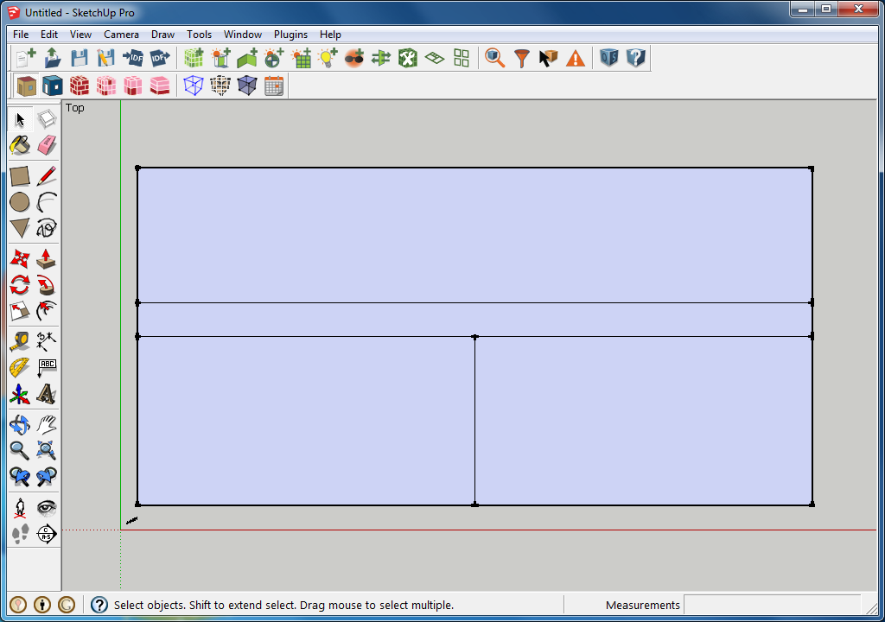

Figure .1 - Building footprint diagram

* 1. Use the pencil tool to split up the footprint to represent spaces shown in (). 
     1. SketchUp’s inference engine snaps to midpoints when hovering the cursor close to a midpoint.
  2. Extrude the footprint into a two-story building.
     1. Select all the surfaces in your footprint with the “Select” tool. 
     2. Click the “Create Spaces from Diagram” button. 
     3. Keep the default floor to floor height of 10’ and set number of floors to 2. Then click “OK”.

Tip: You can double click to enter into a space, at which point you can alter or create geometry. New geometry will be classified as OpenStudio objects.

* 1. Set surface boundary conditions.
     1. Change to “Render by Boundary Condition” mode. 
     2. Click the “Surface Matching” tool and choose “Match in Entire Model”. 
     3. Use the x-ray mode or section cut to confirm green interior surfaces inside the model. You can delete the section cut when you are done. 
     4. Blue represents outdoor, tan is ground, and green is a surface boundary condition.

Tip: Matched surfaces should be the same size and in the same position. The “Intersect Entire Model” button will split surfaces that span adjacent base surfaces.

* 1. Apply a window to wall ratio to the building.
     1. Switch the render mode back to “Render by Surface Type”. 
     2. Select all spaces by drawing a window with the “Select” tool.
     3. Run the “Set Window to Wall Ratio” user script with the default values.
        1. This is under the “Plugins/OpenStudio User Scripts/Add or Alter Model Elements” menu.
        2. Use the default values of “0.4” for fraction, “0.76 meters” for offset, and “Above Floor” for application type.

Tip: The window to wall ratio script removes existing windows but leaves doors alone. If it cannot meet the requested ratio, it will not add a window.

* 1. Search for south-facing windows.
     1. Click “Surface Search” tool. 
     2. Choose “OS:SubSurface” for class, and 180 to 180 for orientation, then click “Search Entire Model” ().

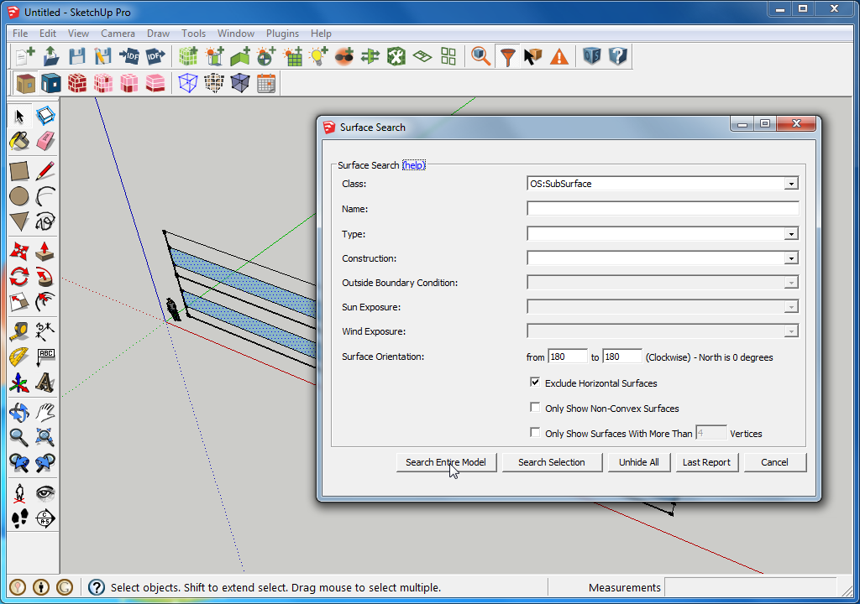

Figure .2 - Search for south facing windows

* + 1. The surfaces that pass the test are visible and selected; everything else is hidden.
    2. Click “View Hidden Geometry” to see the rest of the model in hatched mode. 
  1. Use the overhang script on the search results to add overhangs based on projection factor.
     1. Run the “Add Overhangs by Projection Factor” user script with the default values.
        1. This is under the “Plugins/OpenStudio User Scripts/Add or Alter Model Elements” menu.
        2. Use the default projection fraction of “0.5” and offset of “0”.
     2. Click “Unhide All” in the Surface Search dialog to cancel the filter and see the rest of the model ().
  2. Save the OpenStudio model as “ Model.osm”. 

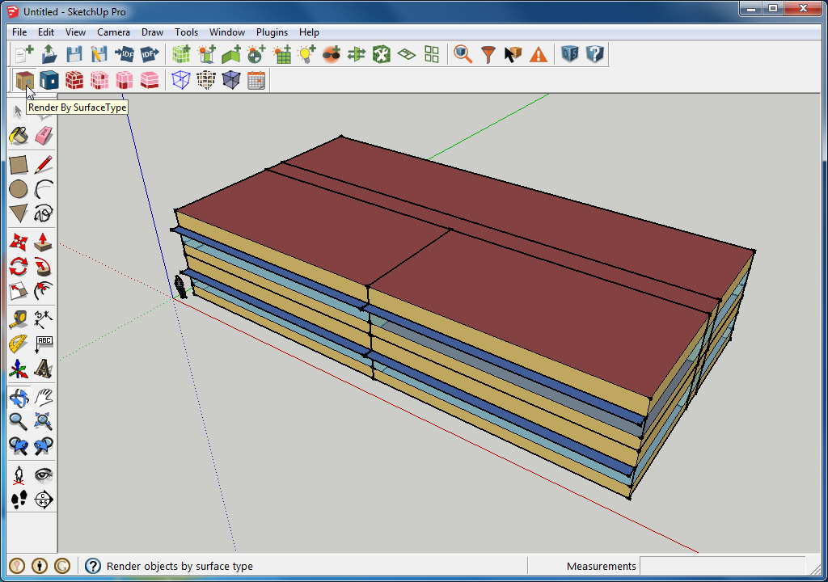

Figure .3 - Completed building envelope

# Customize the Envelope, Fenestration, and Add Site Shading.

* 1. Customize the Envelope.
     1. Use the Extrude tool to raise the roof of the South West space.
        1. Double click the South West space to activate the group.
        2. Raise the roof and then type 10’ and enter.
     2. Draw an edge between the two short edges of the roof with the pencil tool to split it in half.
     3. Hover over the new edge with the move tool, click and raise it vertically by 10’. Make sure you are on the blue axis so the roof is moved vertically. Again type 10’ and enter ( Figure 2.1).

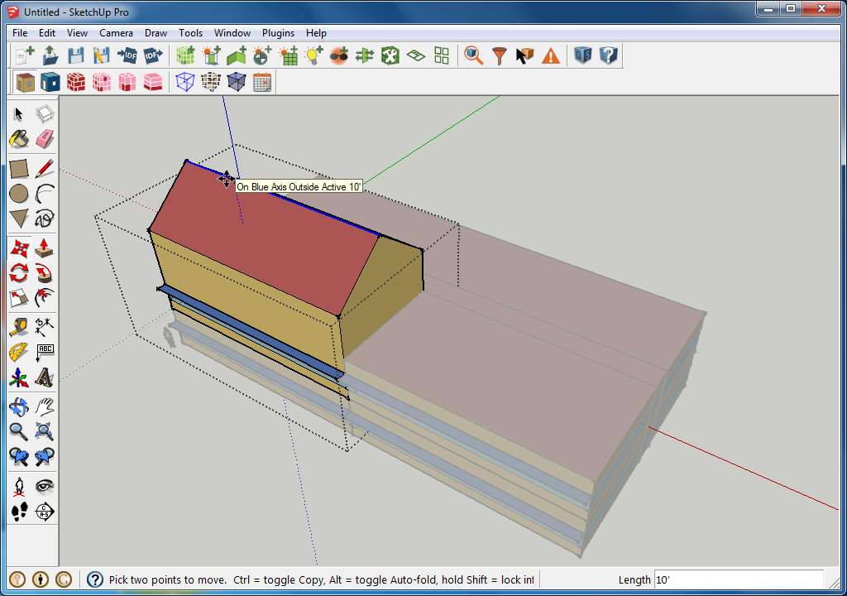

Figure .1 - Customized envelope

* + 1. Change to “Render by Boundary Condition” mode. 
    2. Notice how the exterior walls are still green indicating they are matched to another surface. We don’t want that. Open the Surface Matching dialog and use “Intersect in Entire Model” to split the walls at the old roof level. This is necessary for proper surface matching.
       1. This won’t work if are within a space when you run it. Escape out to the top level of the model.
    3. After splitting the surfaces click “Match in Entire Model” to re-evaluate the surface boundary conditions. Now the lower portion of the wall has surface boundary condition and the upper portion has outdoor boundary conditions. You should now only see green if you have a section cut to expose the inside of the model ().

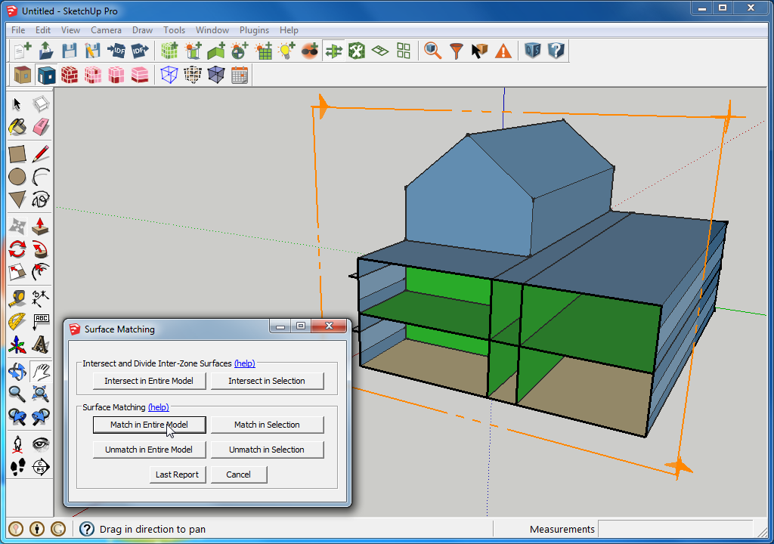

Figure .2 - Model after intersection and re-matching

* 1. Add new fenestration
     1. Hit “esc” or click on the SketchUp background to back out of the space.
     2. Use the rectangle tool to draw rectangle on the south façade starting at the corner of the overhang. Type 6’, 6’ and then press enter to size the rectangle.
     3. Double click the rectangle to select it. Use the move tool to move it over and up 24 inches. You can type 24” to after defining a direction of movement. Do this once for vertical and again for horizontal.
     4. Press the “ctrl” key to turn the move tool into the copy tool. Make a copy of the window 40’ to the right.
     5. Then before you do anything else type /3 and then press enter. This will make 3 copies spaced across the 40 foot span vs. the single copy you first made ().
     6. Lastly, to convert these loose surfaces into OpenStudio objects, open the “Project Loose Geometry” window and choose “Project All Loose Geometry”. 

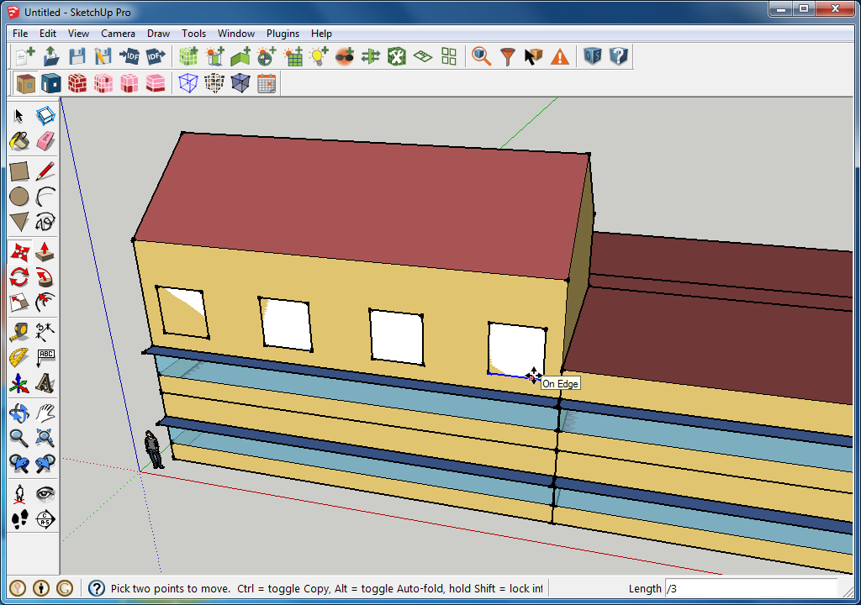

Figure .3 - Ready to project loose geometry

* 1. Add Site Shading.
     1. Click the “New Shading Surface” button and click the South West corner of the building as an insertion point. Then select the purple box (don’t enter it, just click it once) and move it 30’ south. 
     2. Double click the purple box to enter the new shading surface group and then draw a 35’ by 20’ rectangle. Then extrude it up 50’.
     3. You now have 6 shading surfaces, but only two are relevant (the North and East walls). So use the eraser tool to remove the extra walls ().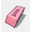
  2. Save the model as “ Model.osm” using the “SaveAs” button on the OpenStudio toolbar. 

Tip: Interior partition surfaces can be added to represent surfaces in a space that are not space boundaries. An air wall construction can be used for space boundaries that do not represent physical walls. Both objects support Radiance simulations; however, they can benefit EnergyPlus simulations as well. You can set the interior partition surfaces to act as internal mass objects.

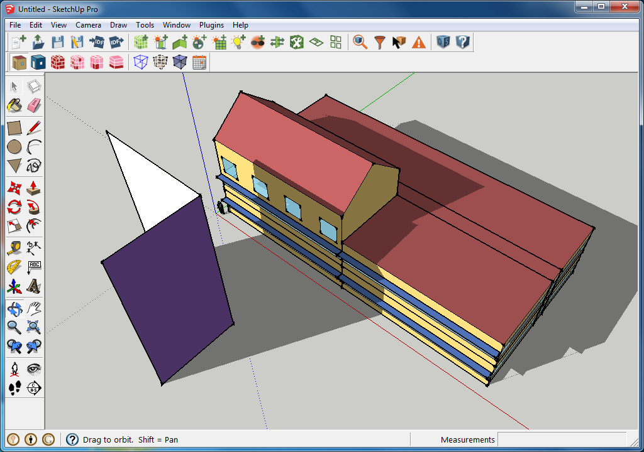

Figure .4 – Model with site shading

# Assign Building Activity and Thermal Zones

* 1. Change to “Render by Space Type” render mode. 
  2. Use the context-aware “Info Tool” to inspect the default space type for this template. It should read “189.1-2009 - LrgHotel - GuestRoom - CZ4-8”. 

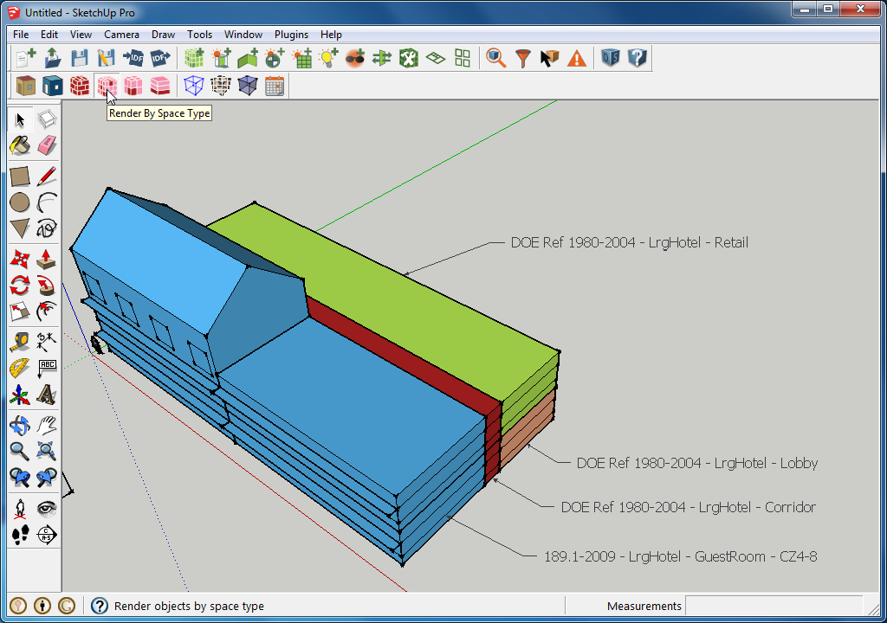

Figure .1 - Render by space type

* 1. Use () as a guide and the “Space Attributes” tool to assign space types. 
     1. You don’t need to change anything on the four guestrooms; they will use the building default space type.
     2. Select the two spaces that will be corridors. It may be difficult to do this with a selection area; an alternative approach is to shift/click while using the select tool to select multiple objects.
     3. Click the “Space Attributes” tool, choose “DOE Ref 1980-2004 - LrgHotel - Corridor” from the “Space Type” pull-down menu, and click “OK”. We will use some other fields later.
     4. Repeat steps and for “DOE Ref 1980-2004 - LrgHotel - Lobby.
     5. Repeat steps and a third time for “DOE Ref 1980-2004 - LrgHotel - Retail”.

Tip: Space Types contain data related to building activity, internal loads, and schedules. They may also contain construction-specific data.

* 1. Change to “Render by Thermal Zone” render mode. We have no thermal zones, so the model should appear white. 

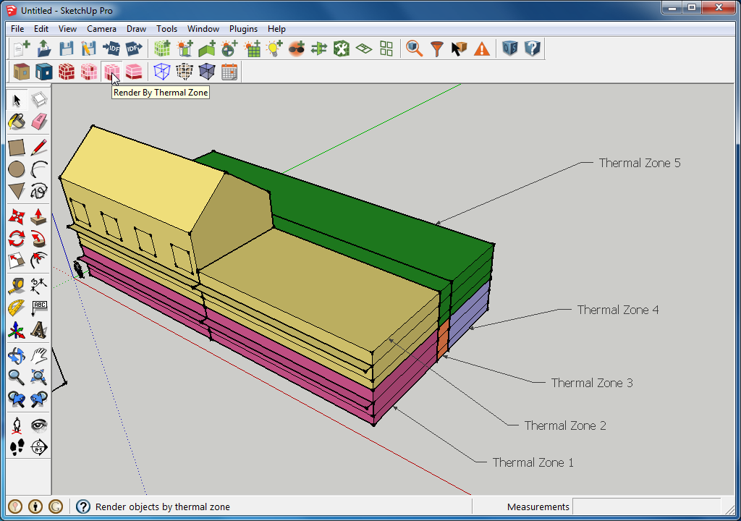

Figure .2 – Render by thermal zone

* 1. Use (Figure 3.2) as a guide and use the “Space Attributes” tool to create and assign thermal zones to your model.
     1. Select the two first floor guest rooms.
     2. Click the “Space Attributes” tool, choose “<new thermal zone>” from the “Thermal Zone” pull-down menu, and click “OK”.

Tip: You can create a new thermal zone and assign spaces to it, or you can choose from thermal zones that are already in the model. For this exercise we will always make a new thermal zone.

* + 1. Repeat the two steps above for the four additional thermal zones. To keep your model consistent with the one used for this exercise, add your zones numerically from low to high. The zone names should then match what is shown in ().
    2. Colors will not be the same, but that is OK. If you want to change thermal zone colors, you can use the paint bucket tool with an alt/click to edit the paint color. 

Tip: One or more spaces can be contained in a thermal zone. These spaces can have different space types.

Tip: You can rezone your building without altering any geometry. Just reassign spaces to different thermal zones.

* 1. Assign thermostats and set up the Ideal Air Loads System.
     1. Select all the spaces in your model and click the “Space Attributes” tool.
     2. Near the bottom of the dialog, set “Ideal Air Loads Status” to “Yes” and set “Thermostat” to “DOE Ref 1980-2004 - LrgHotel - Lobby Thermostat”.
  2. Save the model as “ Model.osm” using “SaveAs” under the file menu in the OpenStudio Application.

.

Tip: Note that thermostats are only applied to thermal zones and not applied to spaces.

Tip: Although we used a single thermostat for this exercise, you can have a unique one for each thermal zone.

Tip: Generally you do not need to save your SketchUp file. The OSM file contains all the OpenStudio model data. If you want to save a scene, styles, or non-OpenStudio geometry, saving the SketchUp SKP file may be beneficial.

# Basic Simulation Run in OpenStudio Application

* 1. Click the “OpenStudio” button to launch your model in the OpenStudio Application.
  2. The “Site” tab should be active after you load a model. Click the browse button next to each input box and then pick Chicago for the EPW file and the DDY files. 
     1. You can find these files in the OpenStudio EnergyPlus folder under “WeatherData”  
        *(e.g. C:\Program Files\OpenStudio 1.11.0\share\openstudio\EnergyPlus-8-5-0\WeatherData)*.

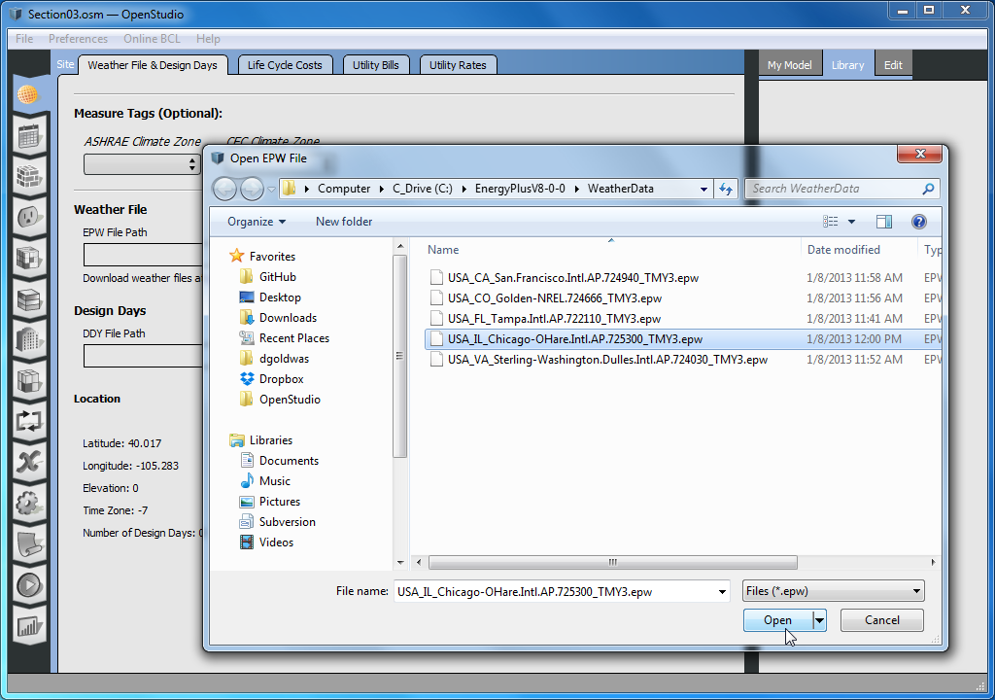

Figure .1 - Site tab of OpenStudio application

* 1. Download and apply a custom reporting measure that will provide annual summary results when you run the simulation.
     1. Go to the “Measures” tab.  and click the “Add Measures from Online BCL” button near the bottom right of the application.
        1. If you don’t see this button then first click “BCL Measures” near the top right of the application first (Figure 4.2).
     2. Click on the “Reporting” category and then look for a measure named “Annual End Use Breakdown”. They are not sorted alphabetically so you may need to go to the second page or search after going to the “Reporting” category.
     3. Check the box for the measure and click “Download”. Close the window when the download is done.

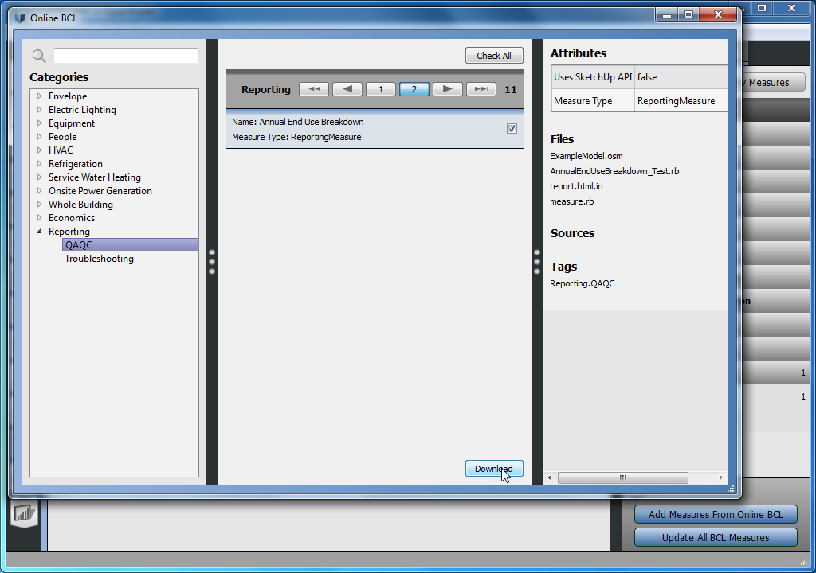

Figure .2- Download measures using the BCL dialog

* + 1. Expand the “Reporting” and then “QAQC” section on the pane at the right, and drag the “Annual End Use Breakdown” measure into the bottom drop zone in the body of the application. (Figure 4.3)

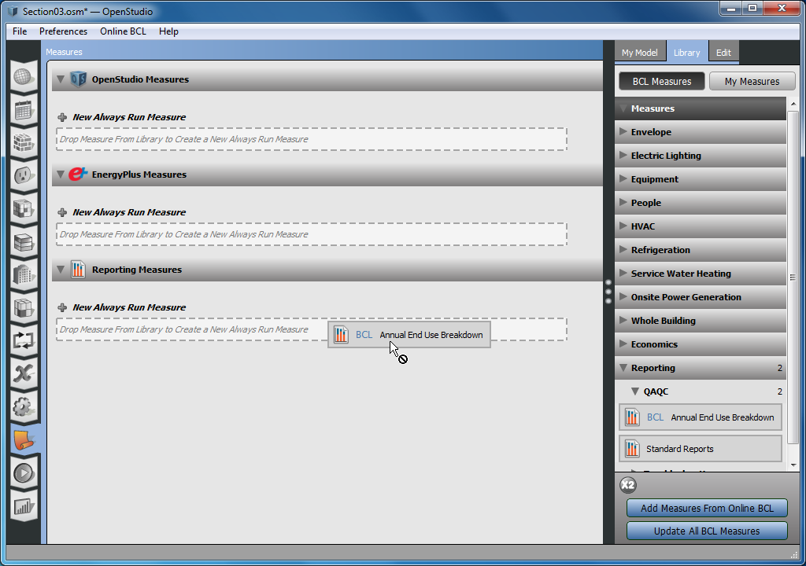

Figure .3- Add measure to model workflow

* 1. Save the model as “ Model.osm” using “SaveAs” under the file menu.
  2. Select the “Run Simulation” tab 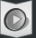 and click the green arrow  to start a simulation.
     1. You can scroll down to view the progress of the simulation (Figure 4.4).
     2. The tree sub-tab shows you the behind-the-scenes workflow for running the simulation. This workflow includes translating your OSM model to an IDF file, which is passed off to EnergyPlus. Results are then passed back to OpenStudio.

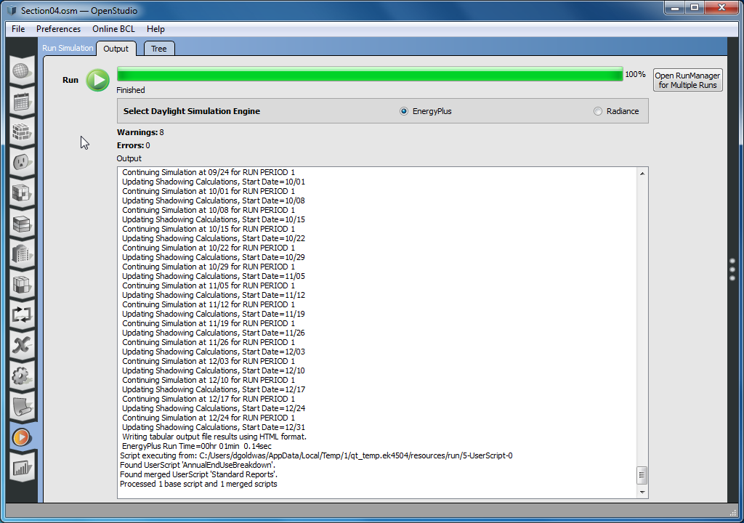

Figure .4- Run tab of OpenStudio application

* 1. Select the “Results” tab to view the simulation results. 
     1. Only lighting, equipment, and fans will show on the monthly overview graphic charts. Heating and cooling for Ideal Air Loads shows up under district heating and district cooling. You can scroll down to see those tables (Figure 4.5). Note that not all the monthly charts generated by OpenStudio are shown in Figure 4.5.
     2. Once you add a full mechanical system, heating and cooling will appear under the electricity and gas charts and tables.

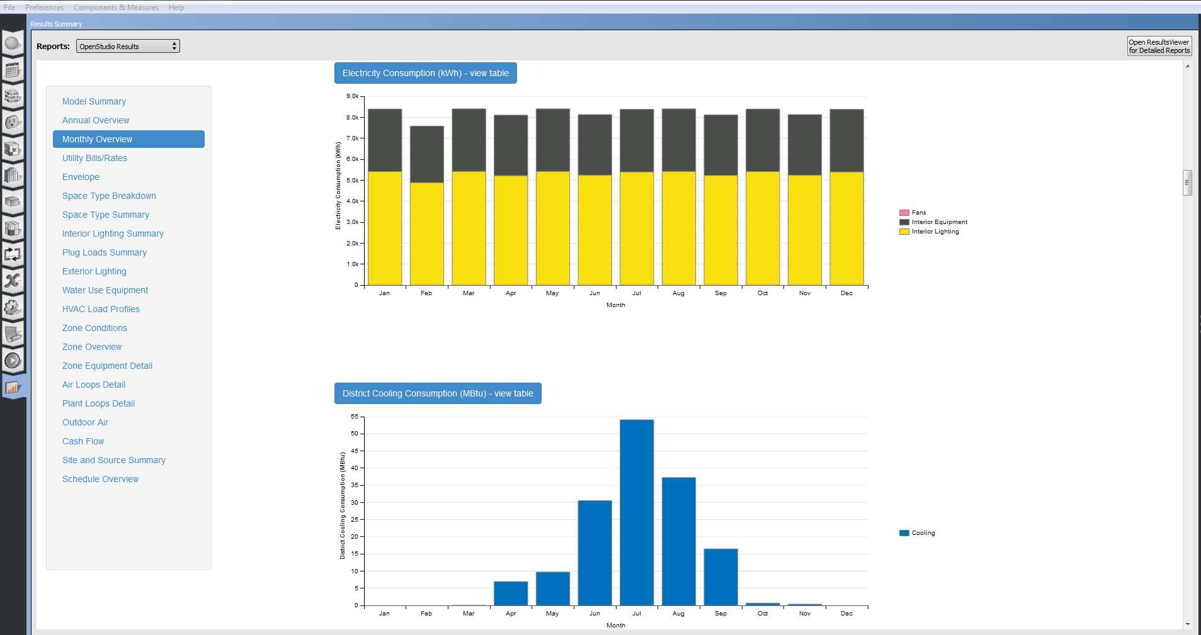

Figure .5 - Results tab for simulation with ideal air loads

* + 1. Choose the “Annual End Use Breakdown” in the “Reports” pull down menu at the top of the reports tab. ()

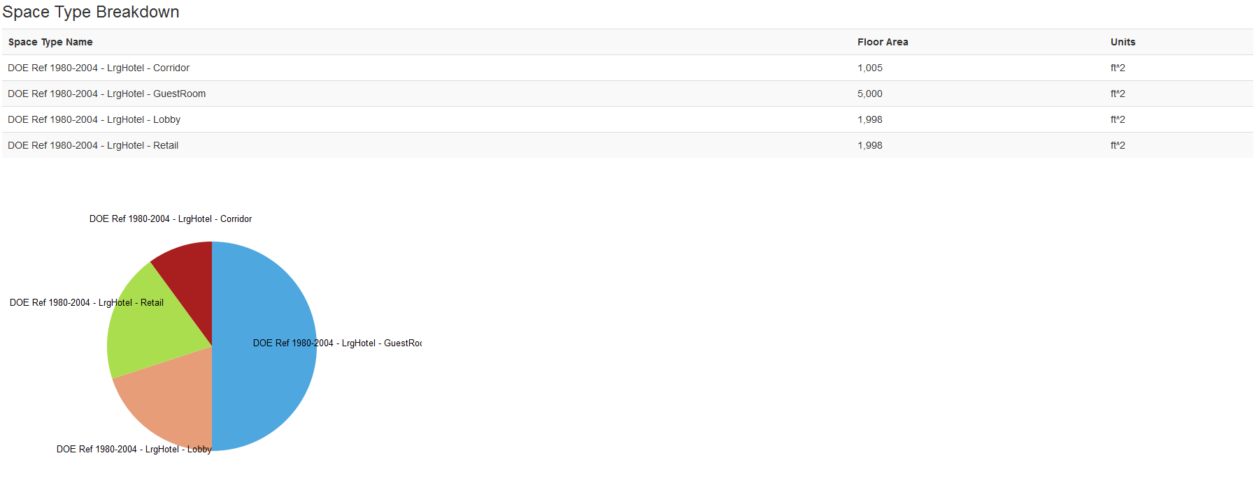

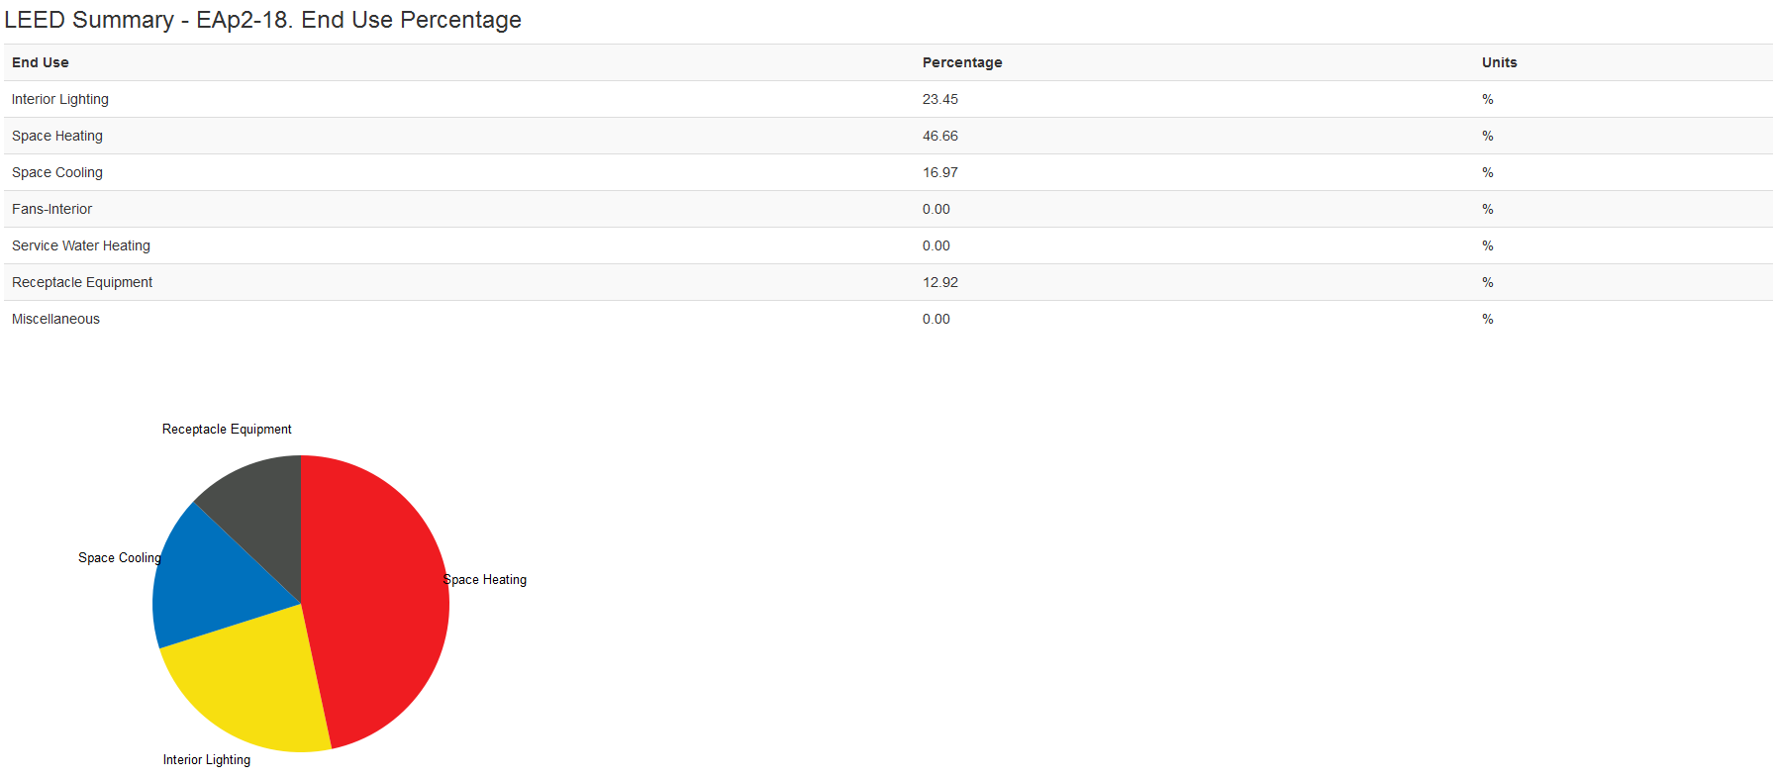

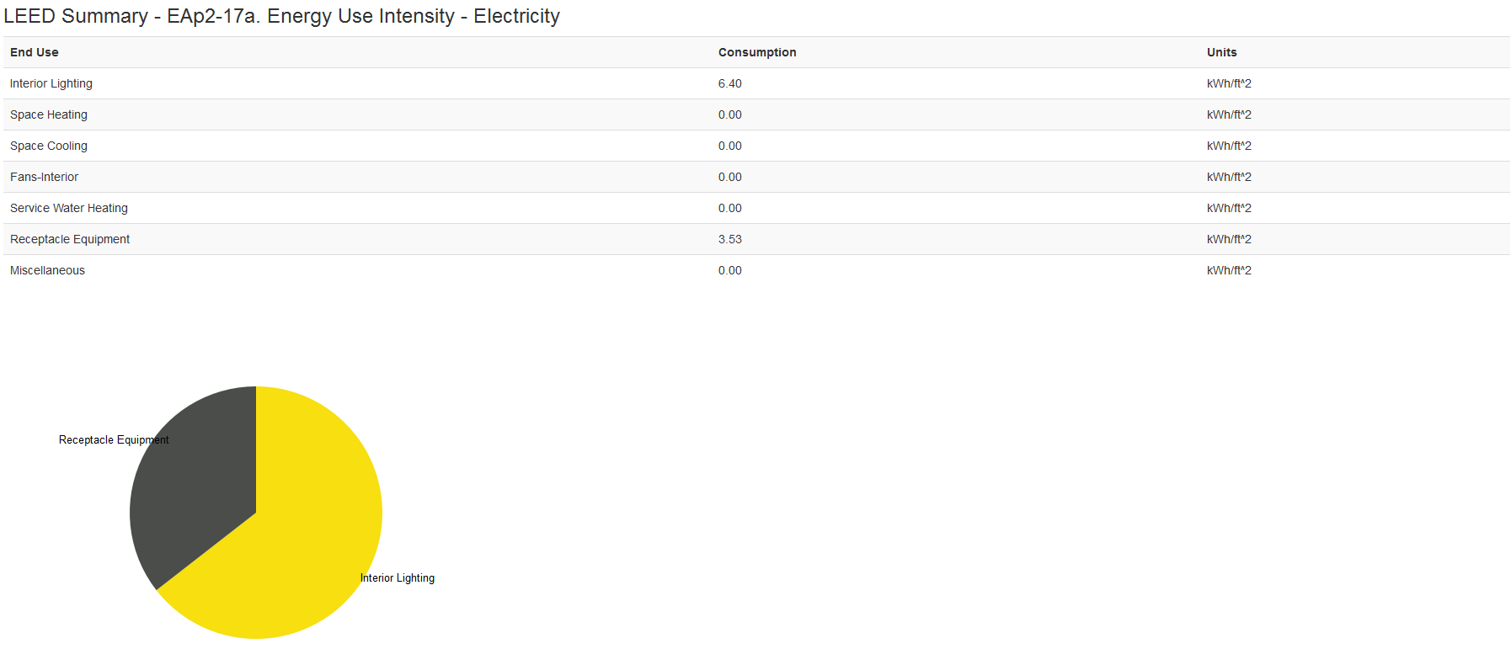

Figure .6 – Annual summary results tab for simulation with ideal air loads (EUI 71.33 kBtu/ft2)

# Adjust Internal Load and Default Construction Values

## SpaceTypes

OpenStudio has a library of built-in space types. These objects contain all loads that the space will require. You can view the details of these sets in the space type 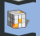 workflow. You can also create your own space types. A space type can be set as a default to the entire model, the floor level or explicitly for each space. The defaulting allows you to quickly default the model to the majority spacetype and could be seen as a timesaver. You can also assign a space type to each space.

### Setting Default Space Type

We wish to default the entire building to a Guest Room space type.

1. Select the “Facility” tab and sort by thermal zone. 
2. Open the “My Model” tab in the right pane and find “Space Types” and expand it.
3. Find the space type named “DOE Ref 1980-2004 - LrgHotel - GuestRoom” and drag it into the “SpaceType” drop zone for the building.

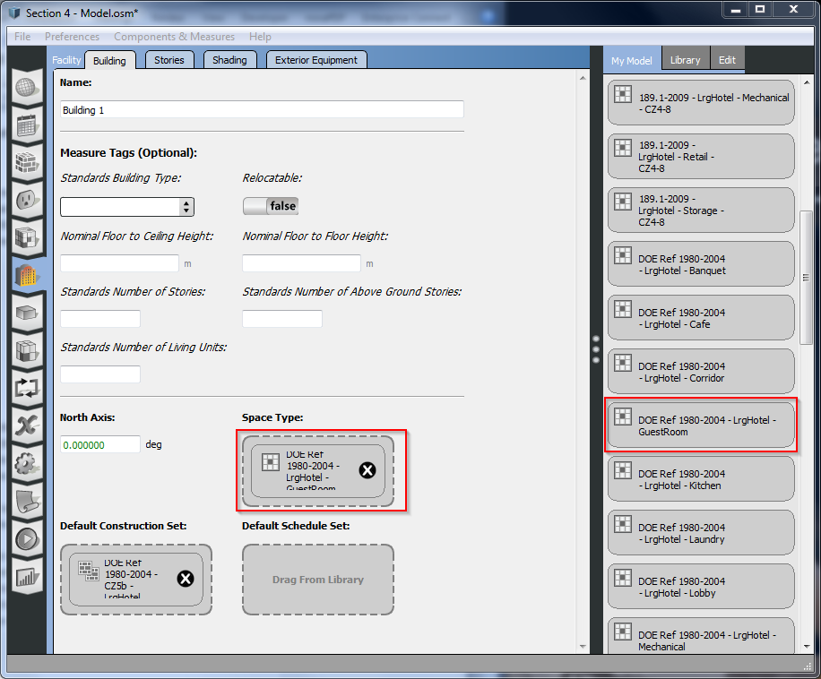

### Explicitly Setting a Space Type to a Space

We wish explicitly change one of the zones to a laundry space type.

1. Select the “Space” workflow tab. 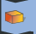
2. Here you will find all the properties associated with the spaces in your model.
3. Go to the “My Model” tab and browse space types for any laundry or kitchen space type, then drag the object over onto the “Space Type” drop zone for space 101.

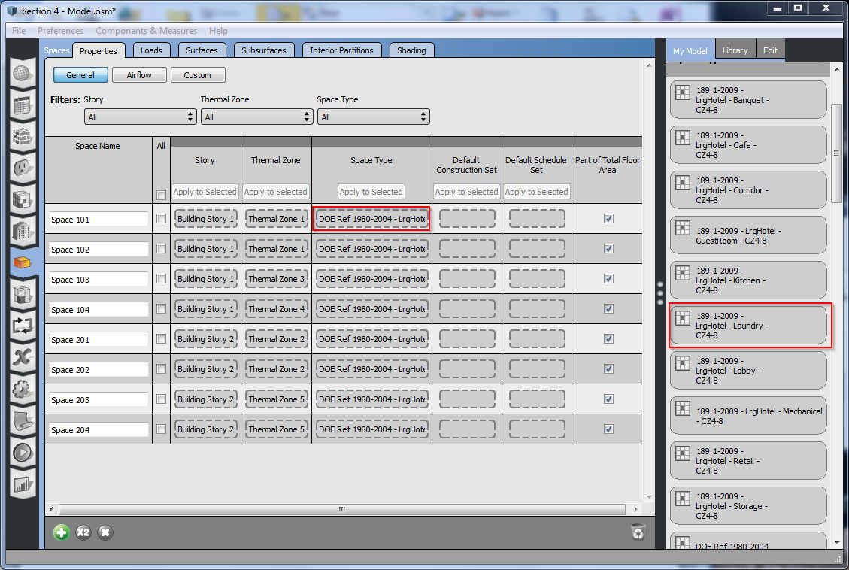

## Construction Sets

OpenStudio has a library of built-in construction sets. These objects contain all constructions types (wall, floor, roof, ext wall, ext roof, ext floor, door, windows, etc). You can view the details of these sets in the construction workflow tab  if you wish. You can also create your own construction sets. This allows to you reuse construction definitions and share them between models.

A construction set can be set as a default to the entire model and the floor level. This allows you to quickly default the model to the majority construction set and could be seen as a timesaver. You can also assign a a set to each to each space or surface.

### Setting Building-Wide Default Construction Set

1. Select the “Facility” tab and sort by thermal zone. 
2. Find the “Default Construction Sets” section in “My Model”.
3. Find the set named “DOE Ref 1980-2004 - CZ5b - LrgHotel” and drag it into the “Default Construction Set” drop zone for the building.

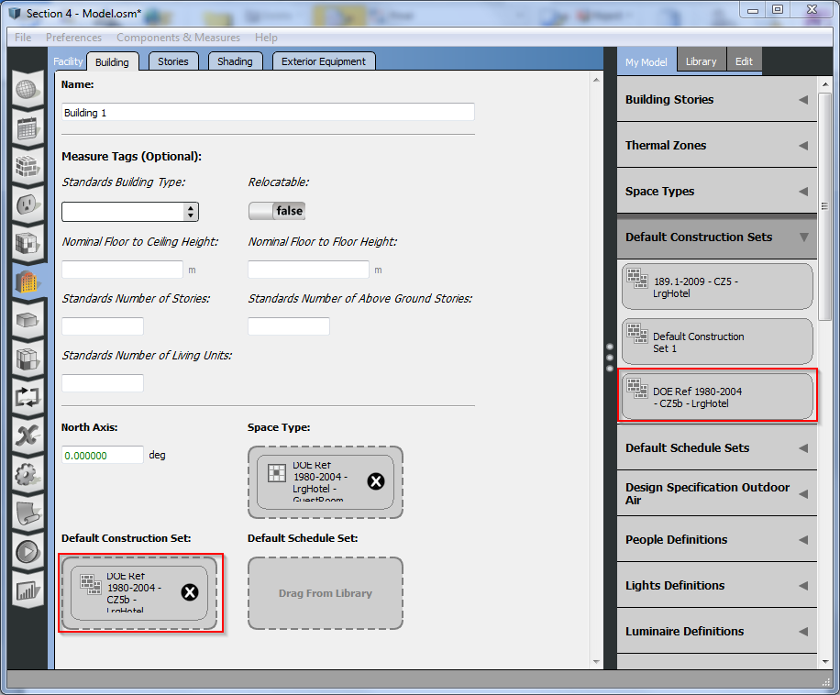

You can now check the “Space” workflow tab -> Surface Tab and see the constructions assignments that have been defaulted are green to the 1980-2004 vintage. You could override any surface by dragging a construction from Constructions section in either “My Model” or “Library”.

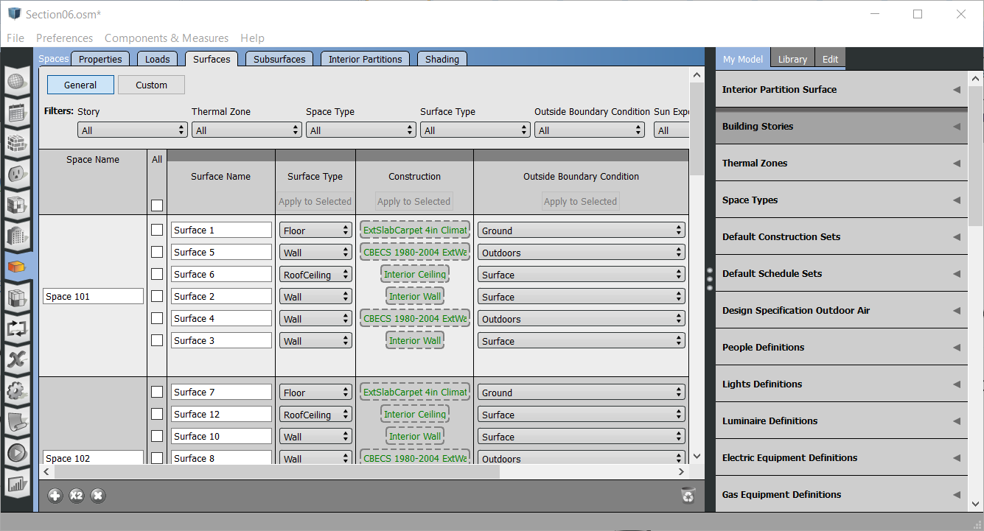

## Thermal Zones

Thermal zones were set using the Sketchup interface in Section 3. However we can make modifications to the zone assignments to the spaces in the “Space” workflow tab. The model editor can also allow you to fine tune thermal zone characteristics.

### Editing Assignment of Zones to Spaces.

1. Select the “Space” workflow tab. 
2. Select the “Thermal Zone 1” assignment for Space 101 and delete it from the space using the “X” button. This should leave this space unassigned.

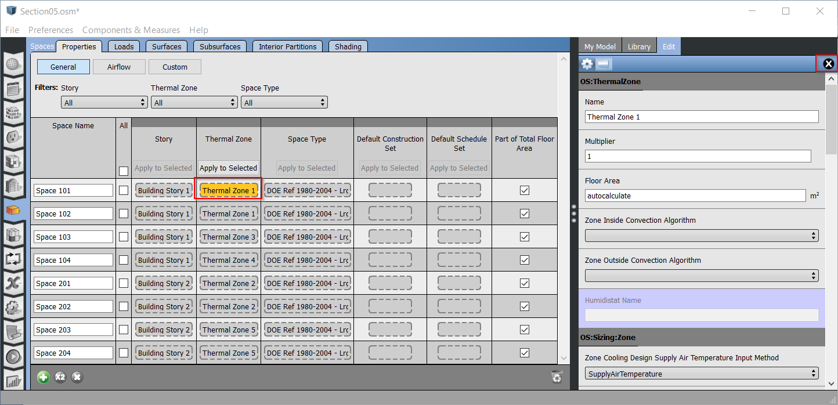

1. To re-assign the space to the zone, go to “My Model” and expand the “Thermal Zones” section.
2. Drag the “Thermal Zone 1” object to the Thermal Zone block for “Space 101”

Tip: If a space is not part of a thermal zone, then that space will not be part of the EnergyPlus simulation.

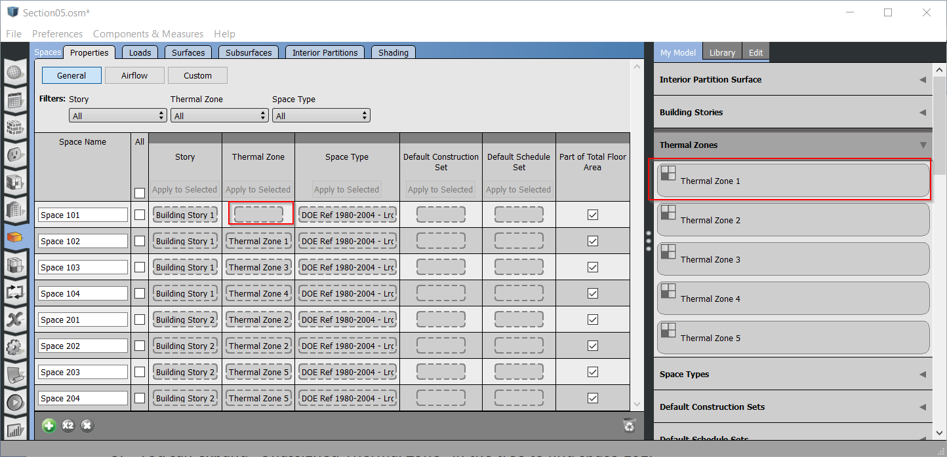

## Adjusting Lighting Loads

Sometimes you will need to adjust the load for a specific item. For example we would like to upgrade the lighting to a newer code standard, but keep the rest the same. This is how you would do this using the interface.

1. Select the “Space Type“ tab 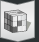
2. Go to the “Loads” area and choose “Lights” as the Load type filter.
3. Go to LrgHotel – Lobby” space type row and select the lobby lighting load name.
4. Click the “X” in the edit tab on the right to remove the load. (Figure )
5. Find the “189.1 2009 Lrg-Hotel-CZ1-3 Lights Definition” and drag it to the empty (figure ()

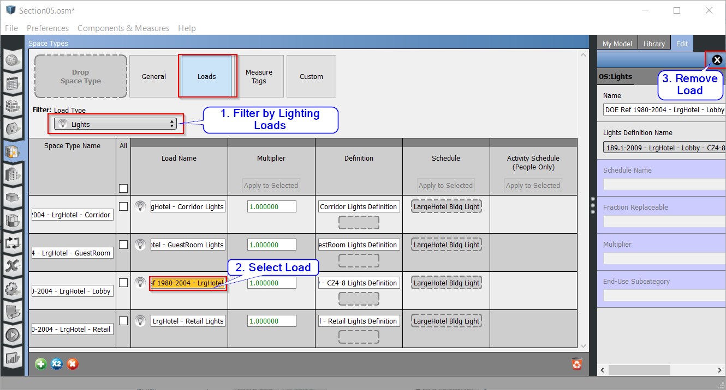

Figure 5.3 - Adding an internal load to a space type in the space types tab

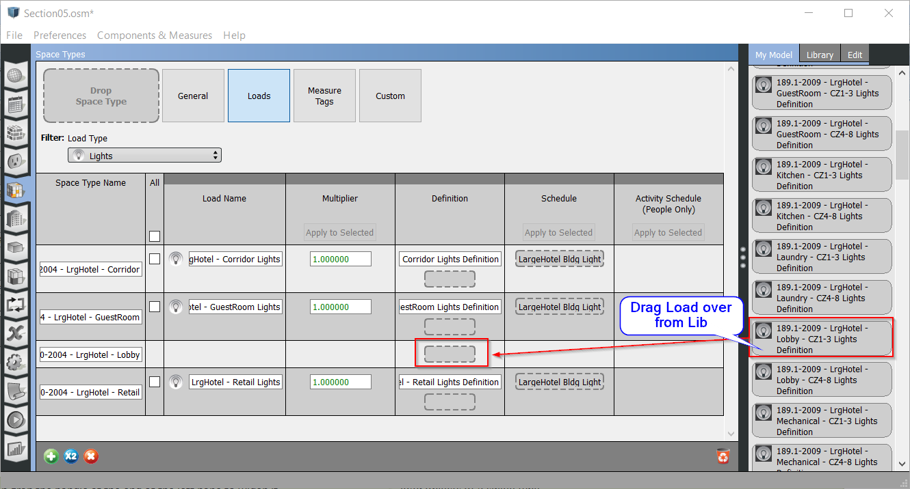

Figure 5.3 - Adding an internal load to a space type in the space types tab

Tip: You can grab the handle at the end of the left pane to widen it.

Tip: You can also add (rather than replace) a lighting object. Spaces can have multiple load objects of a single type.

Tip: Schedules for internal loads can be inherited from a schedule set or hard assigned.

# Add HVAC Systems

## Zonal and Plant Systems

Until now we have been using what is called the ideal HVAC system of energy plus. This means the heating and cooling loads will all be met by a district energy system.

### Adding Zonal Systems

Let’s perform assignment of some zonal systems to some zones. In this example we will add a couple of PTHP to Thermal Zones 1 & 2

1. Click on the “Thermal Zones” tab. 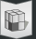
2. Go to the “Library” tab in the right pane (Figure 6.1).
3. Expand the “PTHP” section and drag the object to the “Zone Equipment” drop zone.
4. Repeat the previous step for “Thermal Zone 2”.

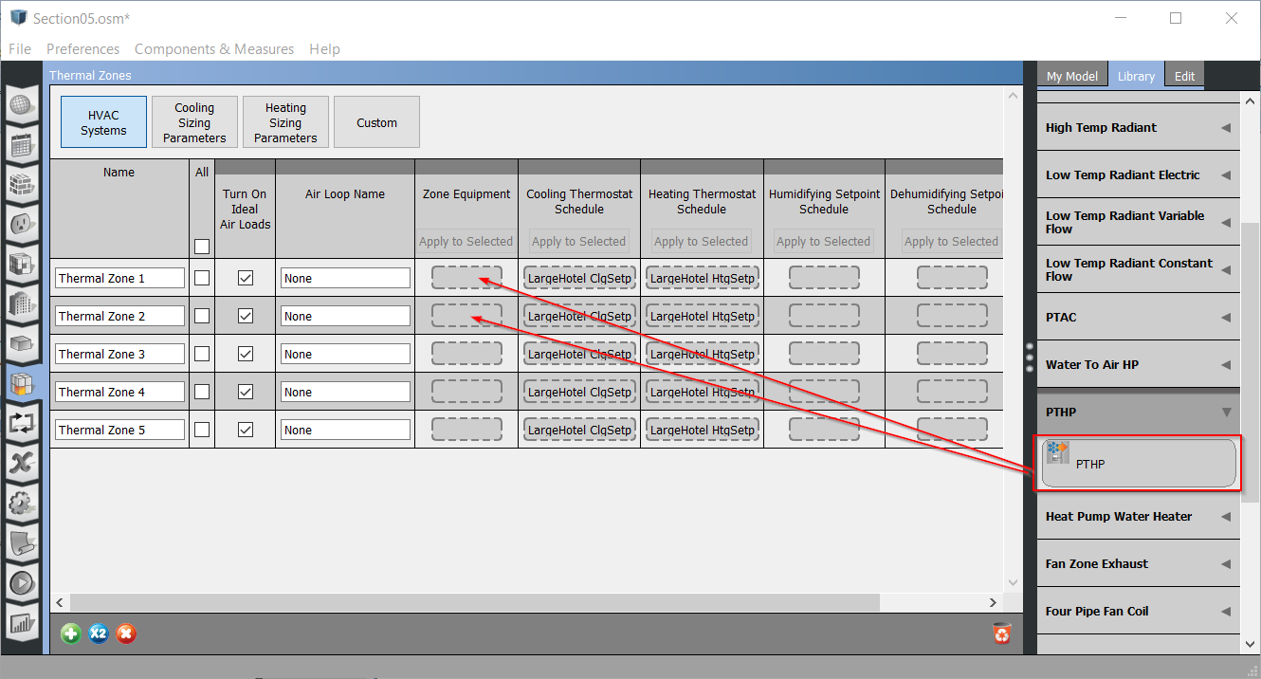

Figure 6.1 - Adding PTHP to a thermal zone in the thermal zones tab

Tip: Adding zone equipment or other HVAC systems to a thermal zone will disable ideal air loads.

Tip: Clicking on the object in the “Zone Equipment” drop zone will open an inspector for the PTHP (Packaged Terminal Heat Pump) system.

### Add air and plant loops to your model.

Let’s add some air and water loops to the model and default some plant equipment.

1. Click the “HVAC Systems” tab, and then click the green “+” near the top right. This opens a library of loop templates. 
2. Choose the one labeled “Packaged Rooftop VAV with Reheat” by clicking “Add to Model”. The four icons represent heating, cooling, fan, and terminal type (Figure 6.2).

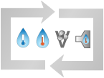

Figure 6.2 – Hydronic VAV with Reheat System Icon

1. Open up “My Model” and drag Thermal Zones 3, 4, and 5 onto the drop zone on the demand side of the air loop (Figure 6.3).

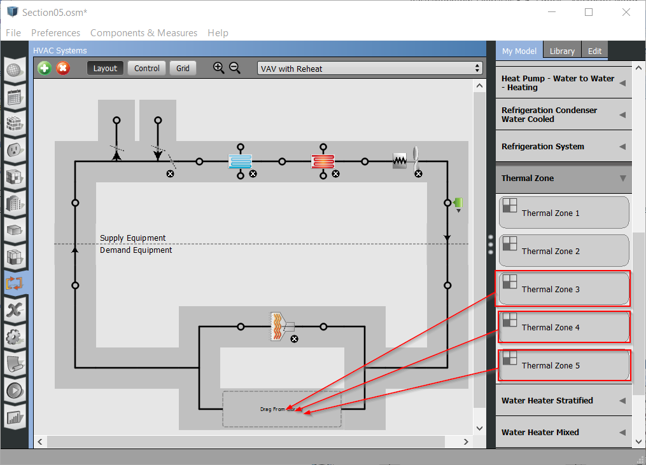

Figure 6.3 - Adding thermal zones to air loop in the HVAC tab

Tip: You can also add thermal zones to an air loop by selecting the splitter or mixer and checking boxes for each zone you want on the loop.

### Inspect the air and plant loops.

1. Click on one of the two dots on the cooling coiling icon to navigate from the air loop to the plant loop. In the plant loop the coil is a demand-side object; the pump and chiller are supply side (Figure 6.4).
2. Click on the dots by the cooling coil icon again to navigate back to the air loop. You can also navigate loops using the pull-down menu near the top right of the main pane.
3. The hot water loops will show additional objects on the demand side for zone terminals with reheat.

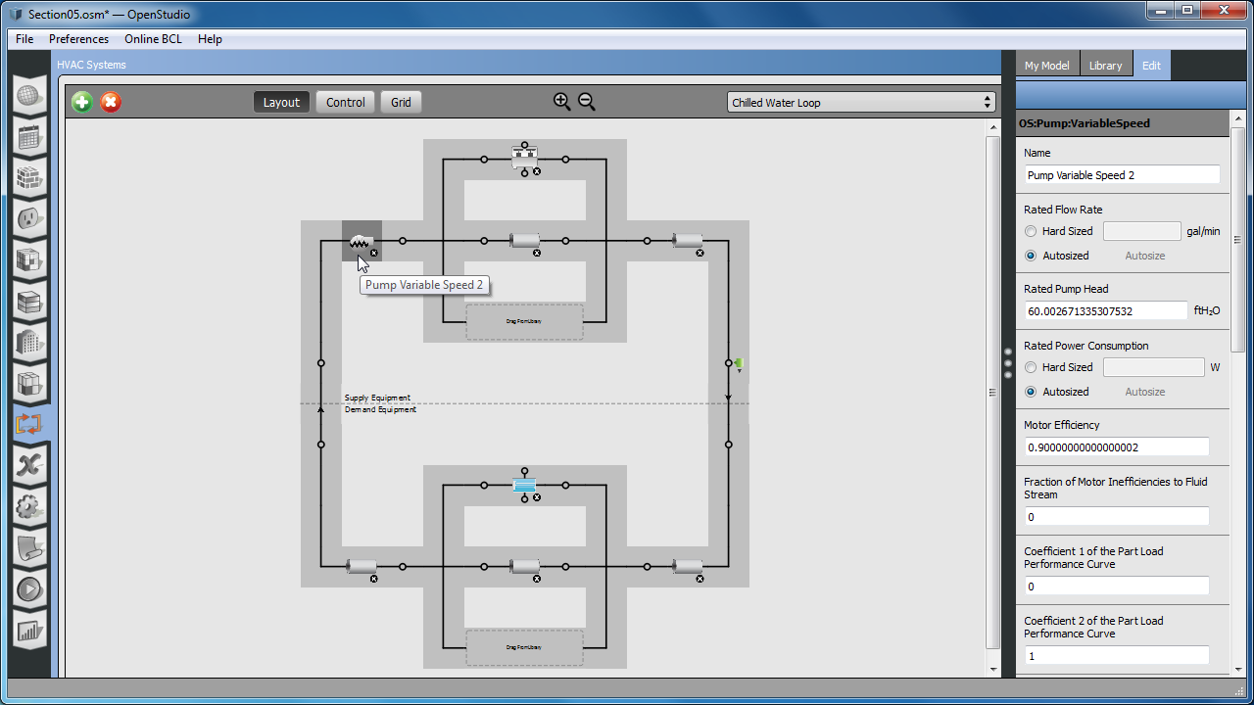

Figure 6.4 - View of cold water loop with variable speed pump selected in the HVAC tab

Tip: Selecting any object on the loop will bring up an inspector in the right pane. An object may have multiple sub-tabs.

Tip: Clicking the “+” and “-“ in the magnifying glass will adjust the zoom level of the loop diagram.

### Re-Run Model with HVAC

1. Save the model as “Section 6 - Model.osm” using “SaveAs” under the file menu.
2. Rerun the simulation. Notice this time that the heating and cooling show up under gas and electric. In the first simulation using ideal air loads, the energy use was shown under district heating and cooling (Figure 6.5) (Figure 6.6).

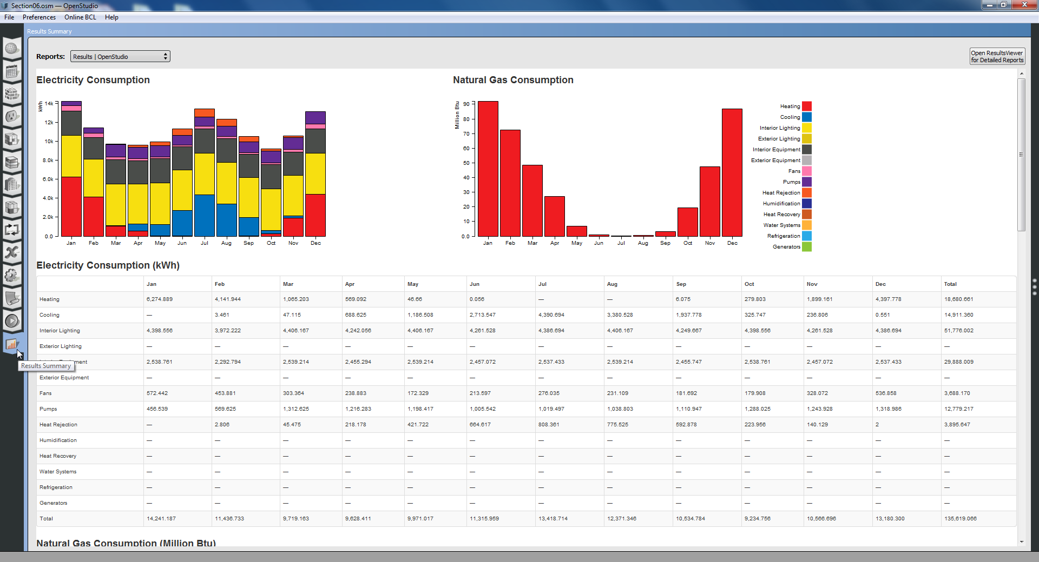

Figure 6.5 - Simulation results with a mechanical system included

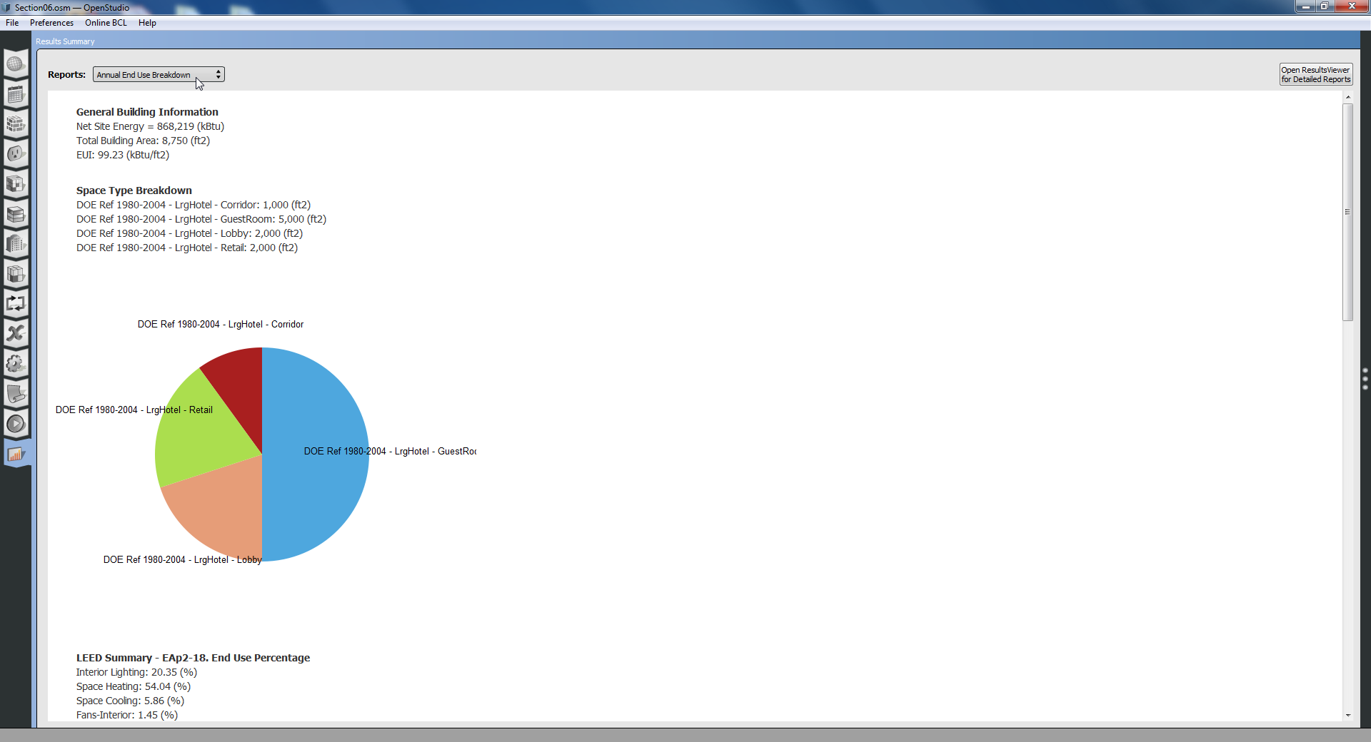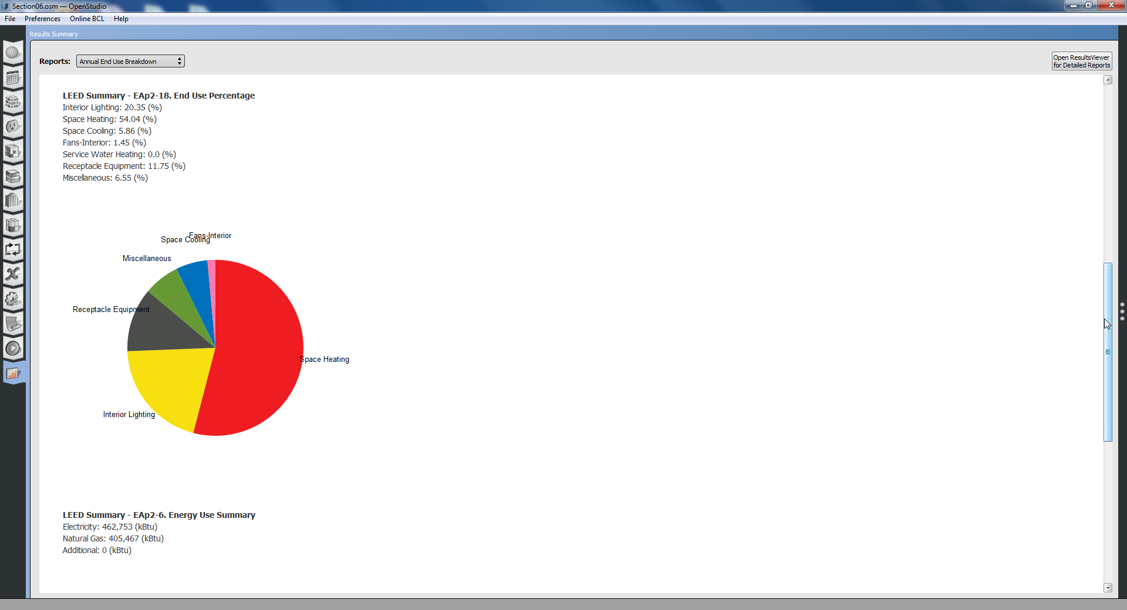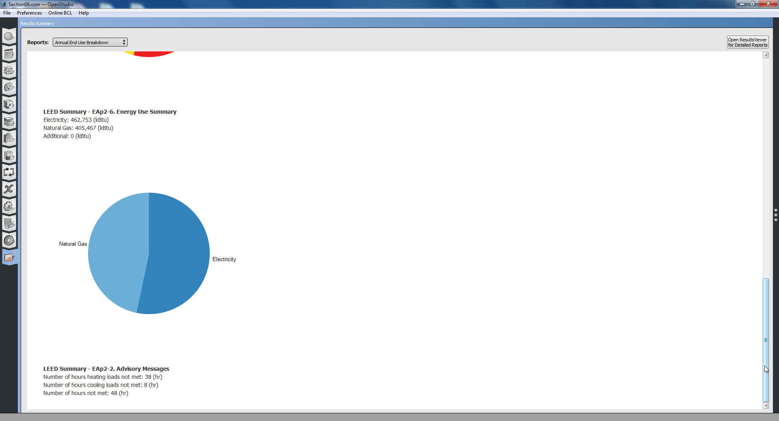

Figure 6.6 - Annual summary results with a mechanical system included (EUI 99.23 kBtu/ft2)

# Refine Fidelity of Loads

## Load Definitions

Let’s dig a bit deeper into the loads. The loads are built by two objects. The Definition, and the Schedule. The Definition contains the max amount that the load value can have, and how it is defined (W/ft2, W, W/person). The Schedules usually fractional and are applied to the Load Definition. They are created separately in the Loads and the Schedule tabs. This allows you to change the load schedule without having to redefine the load definition magnitudes. The following examples will show how to modify the definitions.

### Change lobby lighting from LPD to discrete lights.

We wish to change the lighting definition from a W/ft2 to a 25 fixtures at 20W per space.

1. Click on the “Loads” tab, expand the “Lights Definitions”. 
2. Select the lobby light, and change the value to “20 W” instead of “0.9 W/ft2”   
   (Figure 7.1).
3. This represents a specific fixture versus a lighting power density.

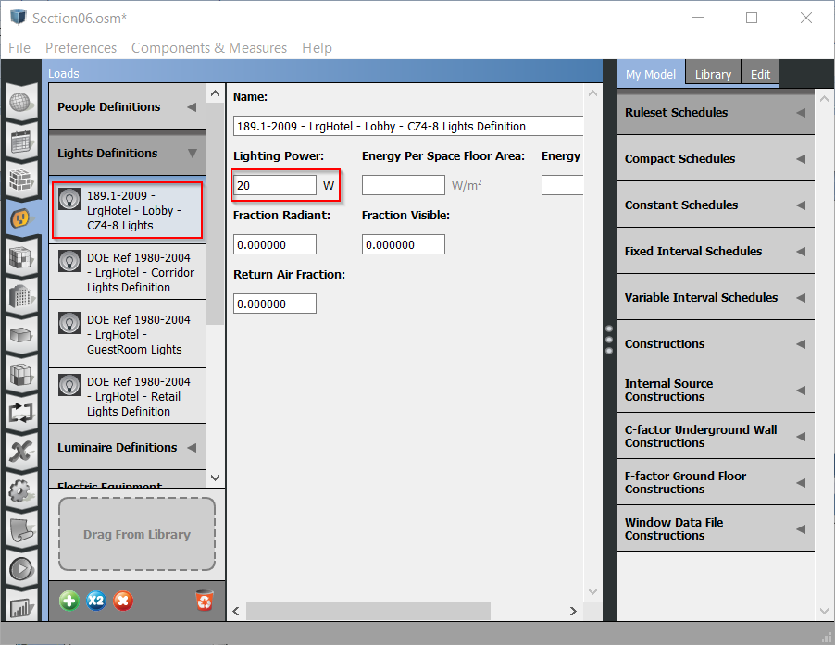

Figure 7.1 – Updated lobby light definition object

1. Now return to the “Space Types” tab and choose the lobby space type.
2. Change the multiplier for the lighting instance to “25” to indicate the number of fixtures in this specific space (Figure 7.2).

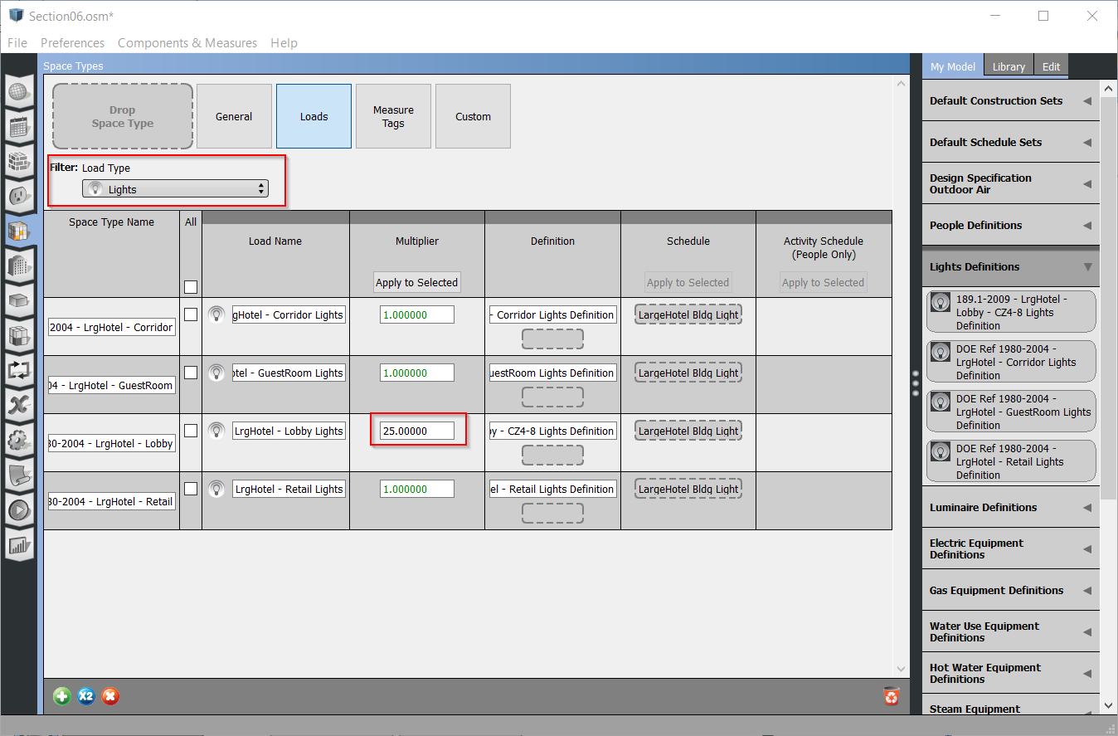

Figure 7.2 - Lobby space type with edited lighting multiplier

## Schedules

In the last section we modified the load definitions. In this section we will modify the schedules. Schedules are not just for loads, they could be used for a controller schedule, an HVAC availability schedule or other items. They are similar to DOE-2 in that there are fractional and ON-OFF schedules and value (think temperature) schedules.

### Altering a schedule

In this example, we will change the schedule for the guest rooms in our Large Hotel model.

1. Click on the “Schedules tab, then “Schedules” sub-tab, then find the schedule named “LargeHotel GuestRoom Equip”. 
2. The schedule contains a number of rules. Each represents a 24-hour profile for specific days of the week and days of the year.
3. Select the run period profile named “Default”. This rule is used for all days not covered by a higher priority rule.
4. This profile has two peaks. Hover over the morning peak, and type “0***.***5”, then click the enter key. This will change the profile. You can also drag the segment vs. typing the value. (Figure 7.6).
5. Next click/hold over the left side of the afternoon peak and drag it to the left so it is at 14:00 hours versus 17:00 hours.
   * At this zoom level, the time step is 1 hour, but you can zoom down to 15-minute or 1-minute time steps.
6. Alter the days of the week for the profiles (Figure 7.6).
   * Select the “Priority 1” rule and uncheck Saturday. You should now see the default profile color showing for Saturdays on the calendar at the right.

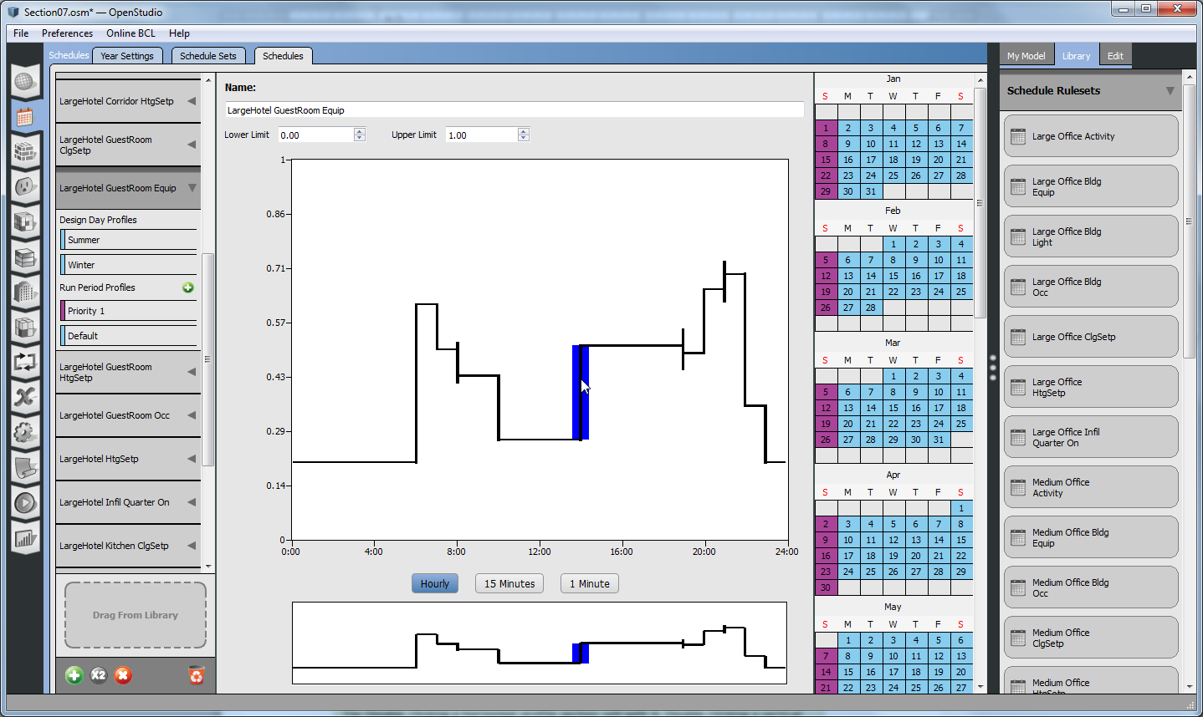

Figure 7.6 - Updated lobby occupancy schedule

Tip: Double clicking a horizontal profile section will split it. Double clicking a vertical section will delete it.

Tip: The default profile is a catch-all. It has no option for the day of week or year.

Tip: The Schedule Set sub-tab looks similar to Construction sets. It is a holder for the typical schedules to use for a space type or a number of space types. For internal loads the schedules can be overridden for a specific space or instance.

## Refine Fidelity of Constructions

In our model we want the first floor to have a different construction set than the rest of the building. We there are two ways to deal with this.. We could apply a construction to each of the exterior surfaces manually, or we can take advantage of the construction sets and defaulting. The latter is faster, so we will make a new construction set to apply only to spaces on the first floor.

### Create a new construction set

1. Click on the “Constructions” tab and then purge unused items. 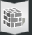
2. Click the green “+” at the bottom to add a new construction set.
3. Go to the “My Model” and find the construction named “ASHRAE 189.1-2009 ExtWall Mass ClimateZone 1”.
4. Drag this to the new construction set as the Exterior Surface Construction for walls. Leave all other drop zones empty (Figure 7.4).

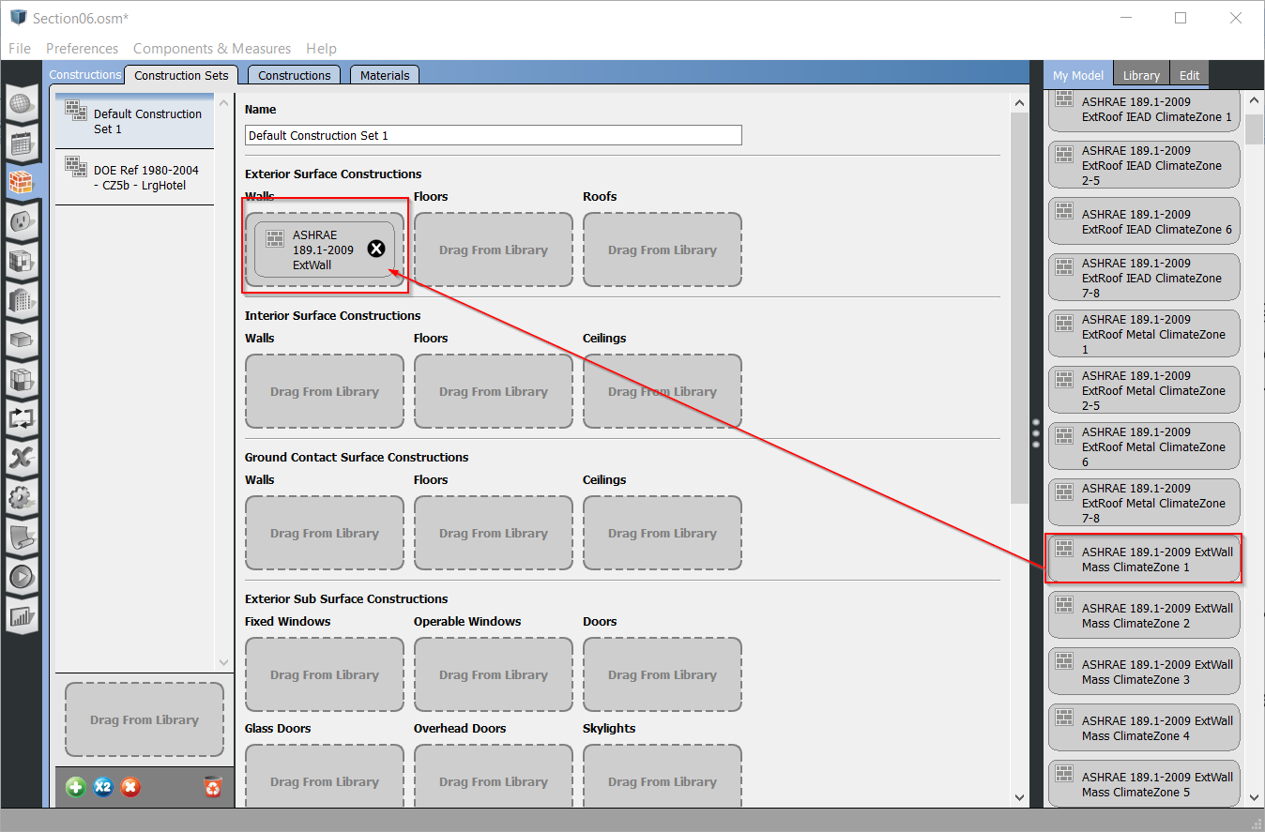

Figure 7.4 - New construction set with exterior wall construction

### Assign a the construction set as default to the 1st floor

1. Click on the “Facility” tab and select the “stories” tab.
2. Go into “My Model”, expand the “Construction Set” section.
3. Drag your new construction set, the default name is “Default Construction Set 1” to the empty “Default Construction Set name” block.
4. If you go back to the Space tab and look at the surface sheet, you will see the external walls have changed, but all other aspects of the model are the same.

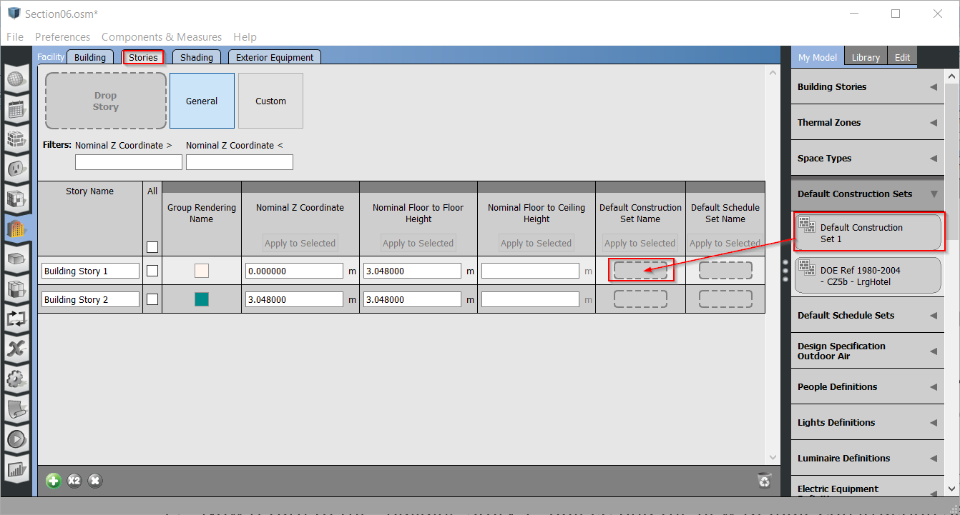

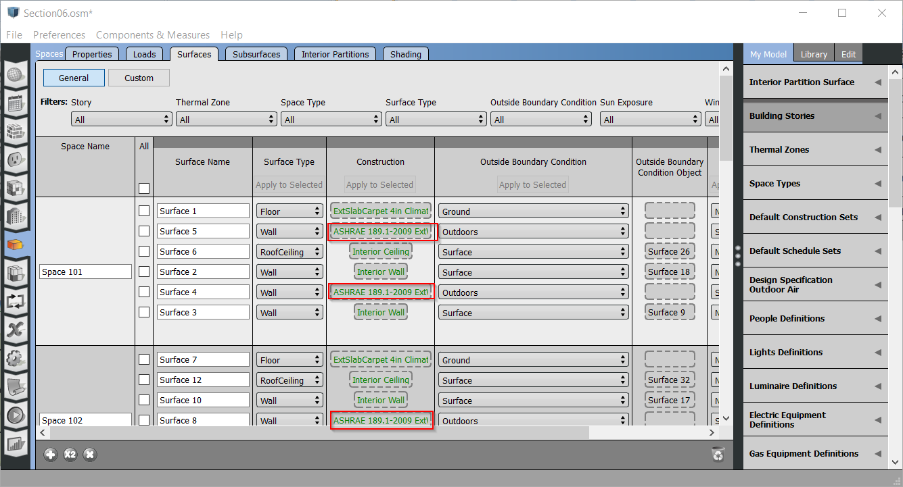

Figure 7.5 - Exterior wall of first story with new construction set applied

Tip: If you want to change a construction for a specific wall, you can drill down to the wall and drop on the appropriate construction.

Tip: You can go to the material sub-tab to edit material properties.

* + Save the model as “Section 7 - Model.osm” using “SaveAs” under the file menu.
  + Rerun the simulation to see how changing schedules has changed the results. (Figure 7.7) (Figure 7.8).

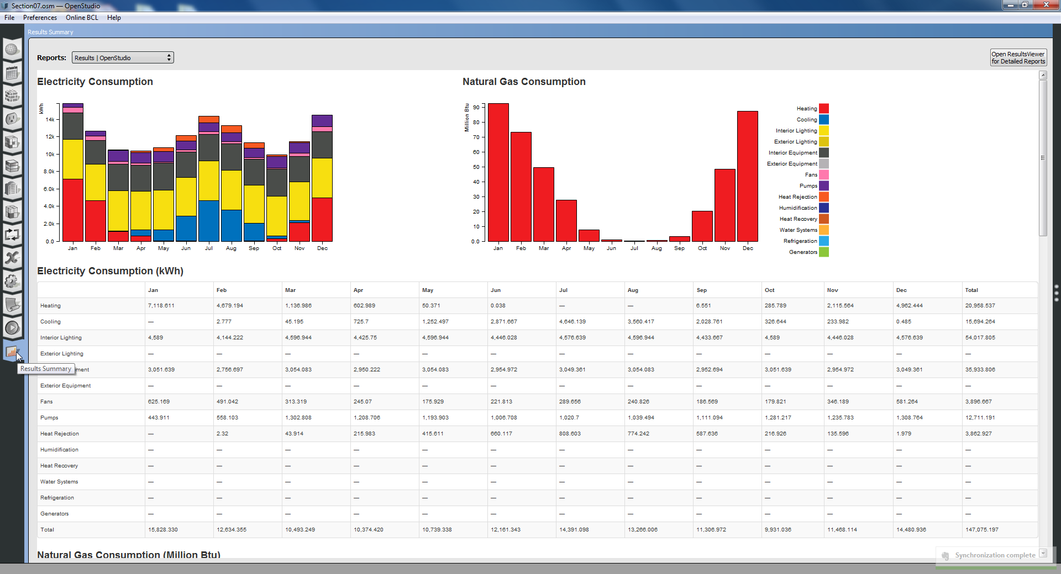

Figure 7.7 - Simulation results with adjusted inputs

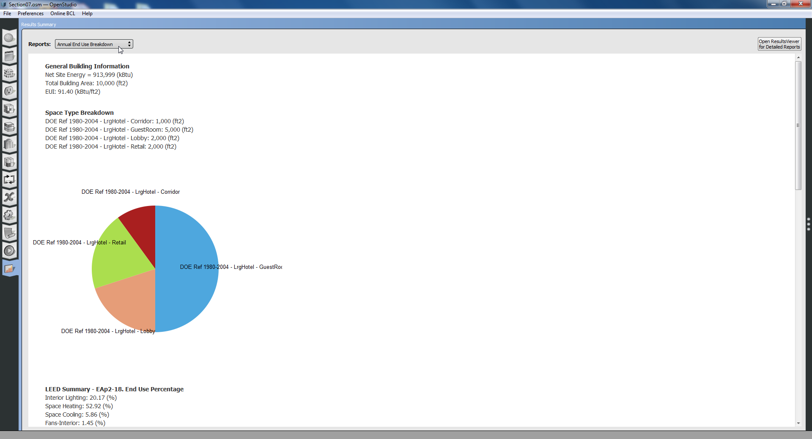 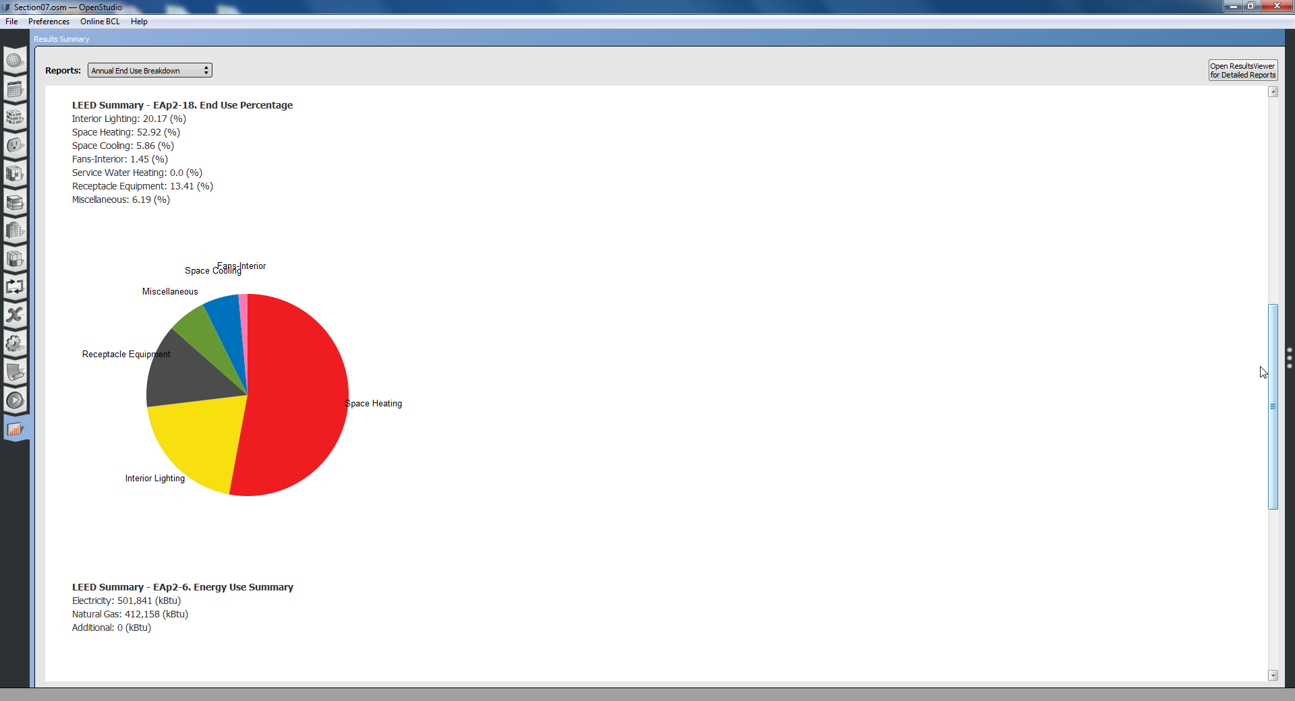 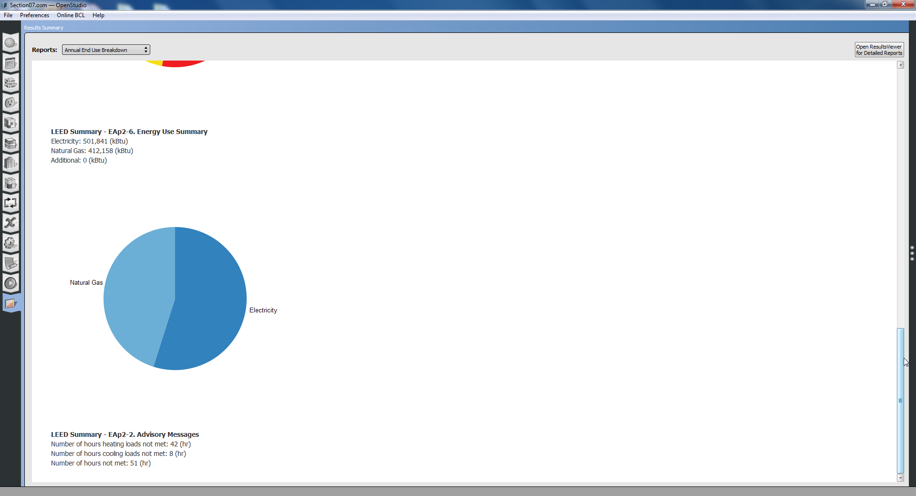

Figure 7.8 - Annual summary results with adjusted inputs (EUI 91.44 kBtu/ft2)

Tip: The OpenStudio SketchUp Plug-in and the OpenStudio application use the same file format. As a result, you can go back and forth between applications, but you must first save your model in one application and then reload or open it in the other. There is no live link. Making changes in both and then saving both will cause data from one to overwrite the other.

# Use Energy Conservation Measure to Shift Operating Hours for Building

1. To access pre-defined measures in the Building Component Library (BCL), you will need to set up an account on BCL and obtain a BCL key. Follow these steps:

# Login to [Building Component Library (BCL)](https://bcl.nrel.gov/) at <https://bcl.nrel.gov/>. Create an account if you don't have one. Follow the instructions from the email sent to you upon registration and then login.

# Click on the My Dashboard near the top right of the website.

# Copy the text after API v1.1 key: then paste the key into the SketchUp Plug-in, the OpenStudio application, or the Parametric Analysis Tool (PAT). **You only need to configure the key in one place and it will be used globally throughout the OpenStudio tools.** Additionally, this key will be maintained when you install updates to OpenStudio.

# Enter the key through the OpenStudio SketchUp Plug-in under the menu Plugins->OpenStudio User Scripts->Building Component Library->Setup BCL Key and click OK. **Or** register the key through the OpenStudio Application under the menu Components & Measures->Find Components. If a key is not already registered, it will prompt you for one.

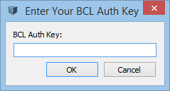

* 1. An alternative to accessing the BCL on-line library directly through the OpenStudio environment is to download the measure directly in from the BCL website at <https://bcl.nrel.gov/nrel/types/measure>; you still need a BCL account.

1. Download an energy conservation measure that shifts the model’s schedules by a user specified number of hours.
   1. For this exercise, download the Whole Building/Shift Schedule Profile Time measure, at the address <https://bcl.nrel.gov/search/site?f[0]=im_field_measure_tags%3A1136> (Figure 8.1)

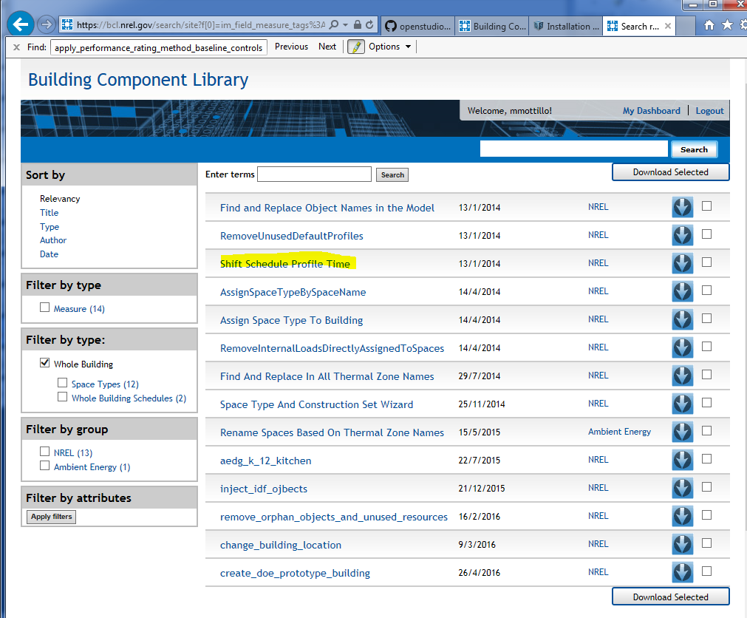

8.1 Download measure from BCL website

* 1. Extract the downloaded zip file to the folder «C:\Program Files\OpenStudio 1.11.0\share\openstudio-1.11.0\pat\Measures». The folder name for this measure is “Shift Schedule Profile Time”. Switch to the “Measures” tab.
  2. Expand “Whole Building” and then “Whole Building Schedules”.’ Select and download “Shift Schedule Profile Time”
  3. Drag the measure into the “OpenStudio Measures” section in the body of the application.
  4. Set argument to two hours.
     1. Select the measure in the main body to expose the arguments.
     2. Change the number of hours to “2”. Leave the first argument alone so it affects all schedules (Figure 8.2).
        1. Optionally you can select a specific schedule to alter.
  5. This measure will be run every time you run your model. You can change the arguments and rerun the model to see how results are impacted. You can also change the order that measures are run in or delete measures entirely.

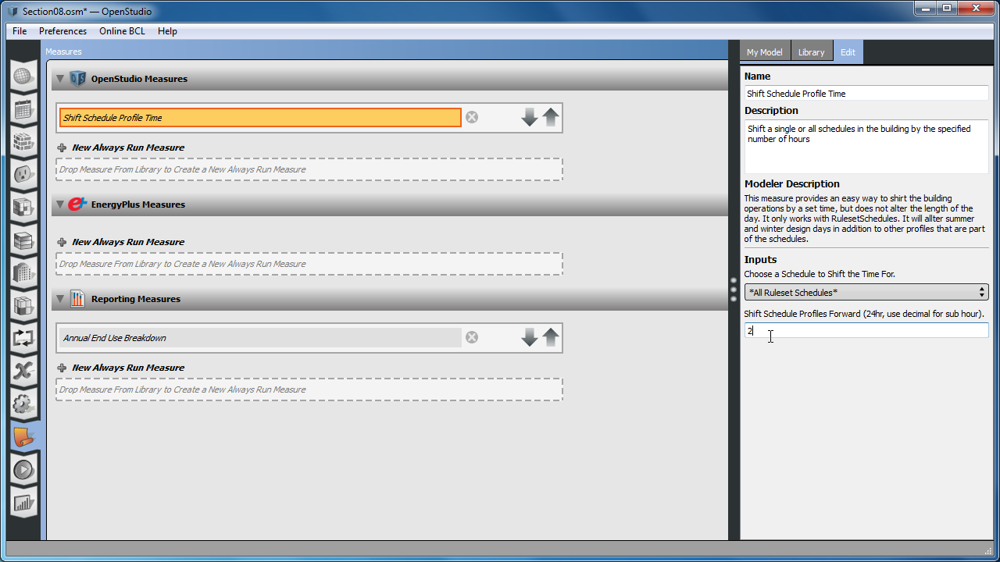

Figure .2 – Set shift schedule measure argument values on measures tab

* 1. Save the model as “Section 8 - Model.osm” using “SaveAs” under the file menu.
  2. Optionally rerun the simulation and look at the results (Figure 8.3) (Figure 8.4).

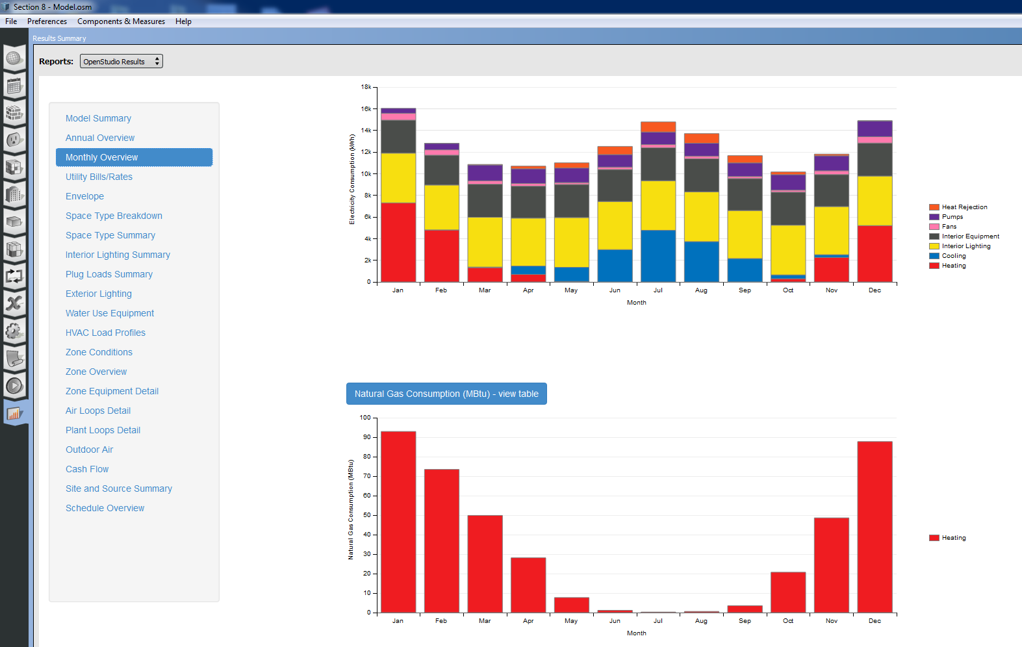

Figure .3 - Simulation results with shifted schedules

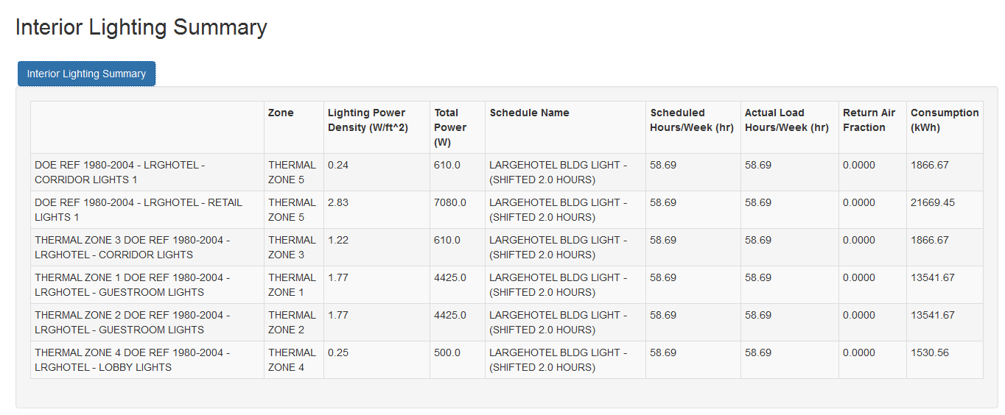

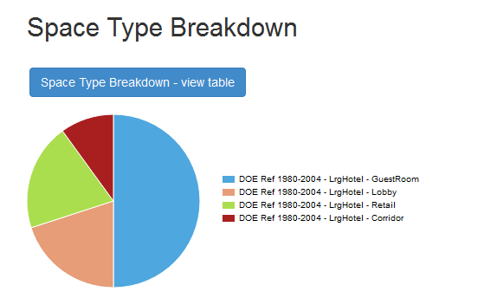

Figure .4 - Annual summary results with shifted schedules (EUI 92.96 kBtu/ft2)

# Add Service Hot Water to the Model

* 1. Save the model as “Section 9 - Model.osm” using “SaveAs” under the file pane.
  2. Add Water Use Connections.
     1. Switch to the HVAC Systems tab.
     2. Use the pull-down at the right of the body to view the “Service Hot Water” diagram.
     3. Scroll to the bottom of the “Library” and click to expand the “Water Use Connections” category.
     4. Drag the water use connections object to the drop zone in the diagram (Figure 9.1).
     5. Repeat the last step to add a second water use connection object into the diagram.

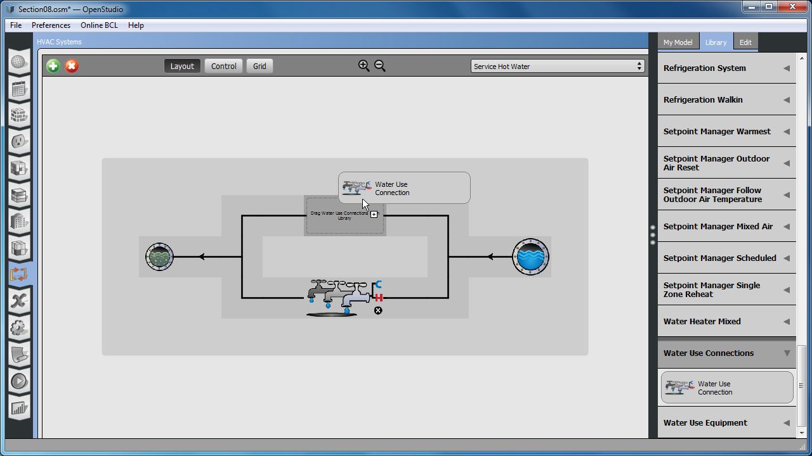

Figure .1- Service water diagram with water use connections

* 1. Add Water Use Equipment Object.
     1. Click the top water use connection object to jump into a detailed view.
     2. Expand the “Water Use Equipment” category in the “Library”.
     3. Drag the sink object to the drop zone on the water use connection diagram.
     4. Repeat the last step to add a second water use equipment object into the diagram.
     5. Select the top water use equipment object to inspect it in the right tab.
     6. Edit the attributes of the water use equipment object.
        1. Rename the object to “Guest Shower 1” .
        2. Associate this object with “Space 101”.
        3. Use the “LargeHotel Guestroom Equip” schedule as the “Flow rate Fraction” schedule (Figure 9.2).
     7. Repeat with the second object on this connection, but name it “Guest Shower 2” and associate it with “Space 102”.

Tip: Associating water use equipment objects with a space is optional. If you don’t assign a space then heat gain from the equipment won’t be included in the simulation. But the energy used to heat the water is still part of the simulation.

* + 1. Click the water main or sewer objects at the right and left to jump back to the main service water diagram.
    2. Repeat the process on the second “Service Water Connection” object. This time rename the two water use equipment objects “Guest Shower 3” and “Guest Shower 4” and associate them with “Space 201” and “Space 202”, respectively.

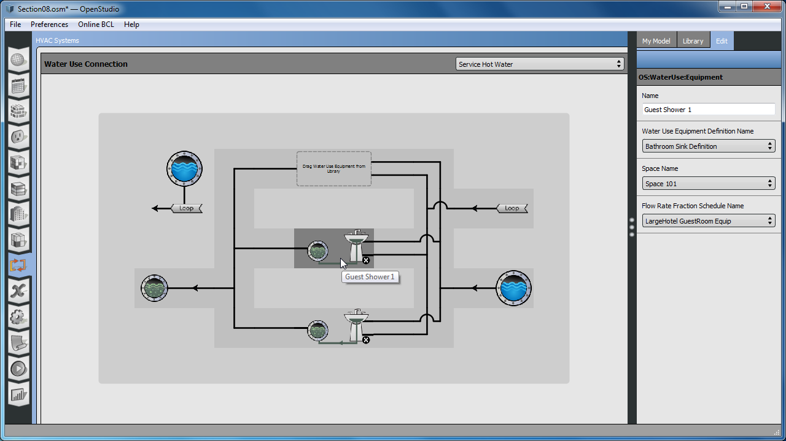

Figure .2 - Water use equipment in water use connection diagram

* 1. Create a Service Hot Water Loop.
     1. Click the water main or sewer objects at the right and left to jump back to the main service water diagram.
     2. Click the green “+” at the top left of the application and create an empty plant loop.

Tip: If you don’t see the green “+” then click the water main or sewer circles to go back to the main interface.

* + 1. Go to the “Library” and find “Water Heater Mixed”. Drag the object under this into the drop zone on the top (supply side) of the plant loop.
    2. Go to “Pump Variable Speed” in the library and drag the object under it to the node on the left side of the supply side of the plant loop (Figure 9.3).

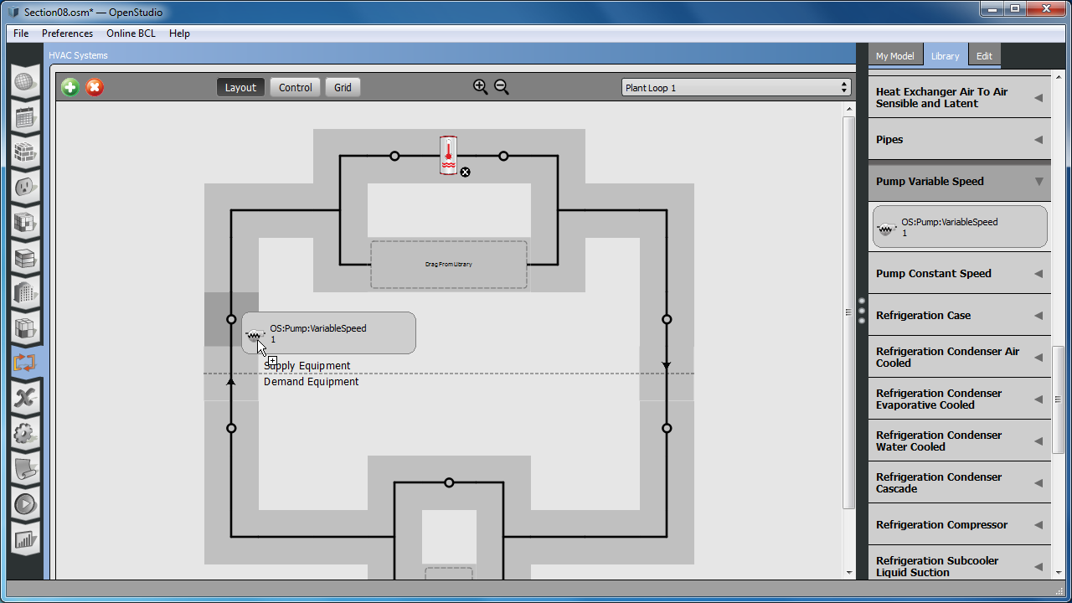

Figure .3 - Adding pump to plant loop

Tip: EnergyPlus requires a pump on plant loops, however you can mimic a small system using main water pressure by adjusting the pumps attributes.

* + 1. Next click and expand the list of “Setpoint Manager Scheduled” objects in the library and choose “Scheduled HW Temp”. Drag this to the node (shown as small circles) on the right side of the supply (top) half of the loop.
    2. Select the newly added “Scheduled HW Temp” so you can inspect the data at the right. Change the schedule name to “Water Heater Setpoint Temperature”.

Tip: The step above sets the setpoint schedule for the plant loop to match what the water heater uses. You can select and inspect the water heater to see this.

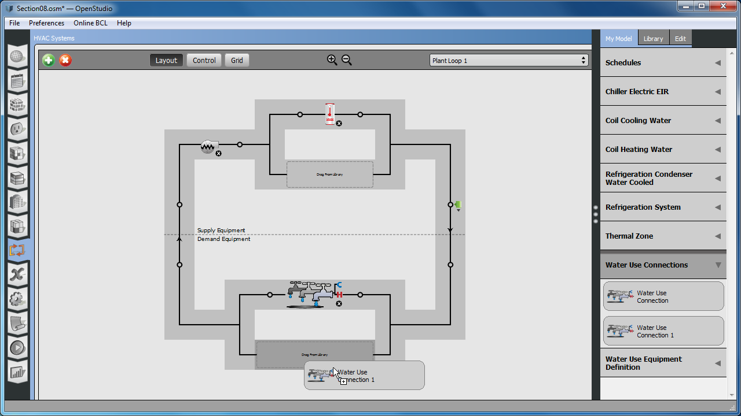

Figure .4 - Adding water use connections to plant loop

* + 1. In “My Model” find the two “Water Use Connection” objects. Drag them into the drop zone on the demand side (bottom) of the plant loop (Figure 9.4).
    2. At this point you are done making water use connections.

Tip: clicking the “Water Use Connection” object in the plant loop will take you to the water use connection diagram. In addition you can now click on the “loop” icons in the water use connection diagram to jump to the newly created plant loop.

* 1. Adjust the flow rate for the “Water Use Equipment Objects”.
     1. Click on the “Loads” tab at the left of the application and expand the “Water Use Equipment Definitions”. While we have 4 instances of water use equipment, they all use the same definition (Figure 9.6).
     2. Change the “Name” to “Bedroom Sink Definition”.
     3. Change the “Peak Flow Rate” from “0.000063m3/s ” to “0.000028317 m3/s”.
     4. Make and assign a schedule for the “Target Temperature”.
        1. Switch to the “Schedules” main tab and then the “Schedules” sub-tab. This is the last one on the right.
        2. Click the green “+” at the bottom left. When prompted with the dialog choose “Temperature” for the class and then click “Apply”.
           1. Leave the other fields as they are.
        3. After the schedule is made, name it “Guest Hot Water”.
        4. The new schedule should show up at the top of the left pane. Click on “Default” just below “Run Period Profiles”.
        5. Hover over the blue horizontal line and set it to “40” Celcius (Figure 9.5).

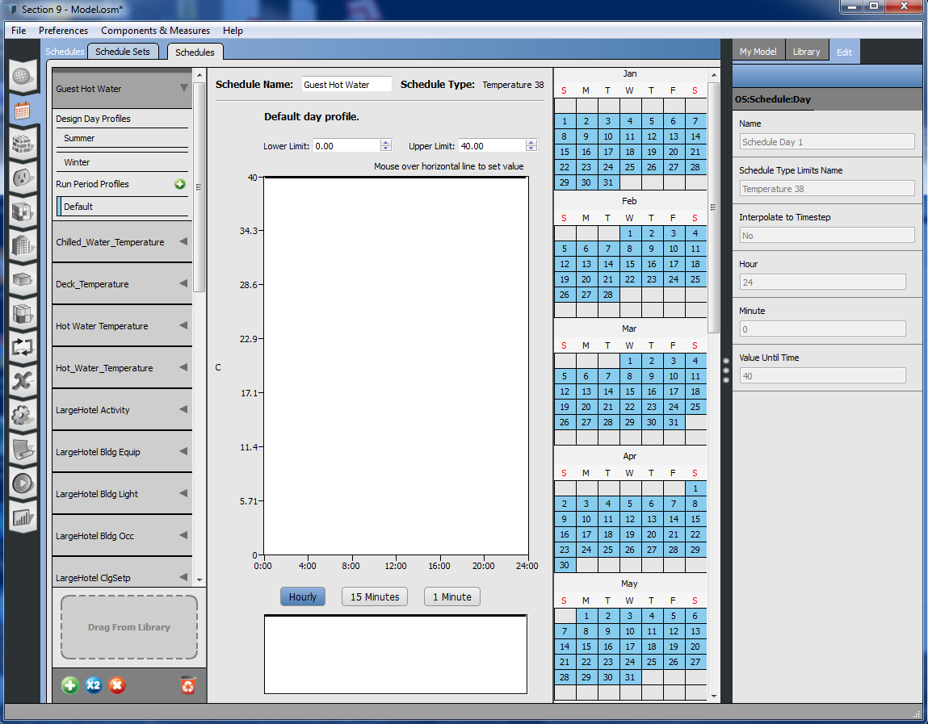

Figure 9.5- Updating hot water temperature schedule

* + - 1. Switch back to the “Loads” tab, select the water use equipment definition, and drag the “Guest Hot Water” schedule from “My Library” (Figure 9.6).

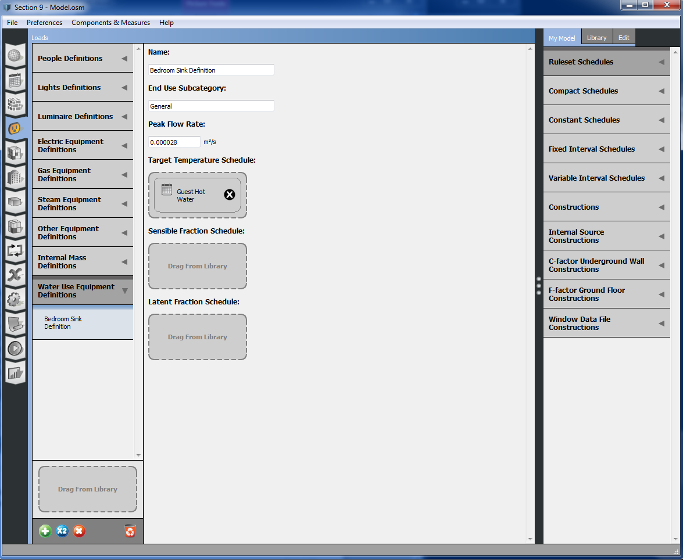

Figure .6 – Updating water use equipment with hot water temperature schedule

* 1. Save your model as “Section 9 - Model.osm” using “SaveAs” under the file menu.
  2. Optionally rerun the simulation. Notice that values show up for “Water Systems. (Figure 9.7) (Figure 9.8).

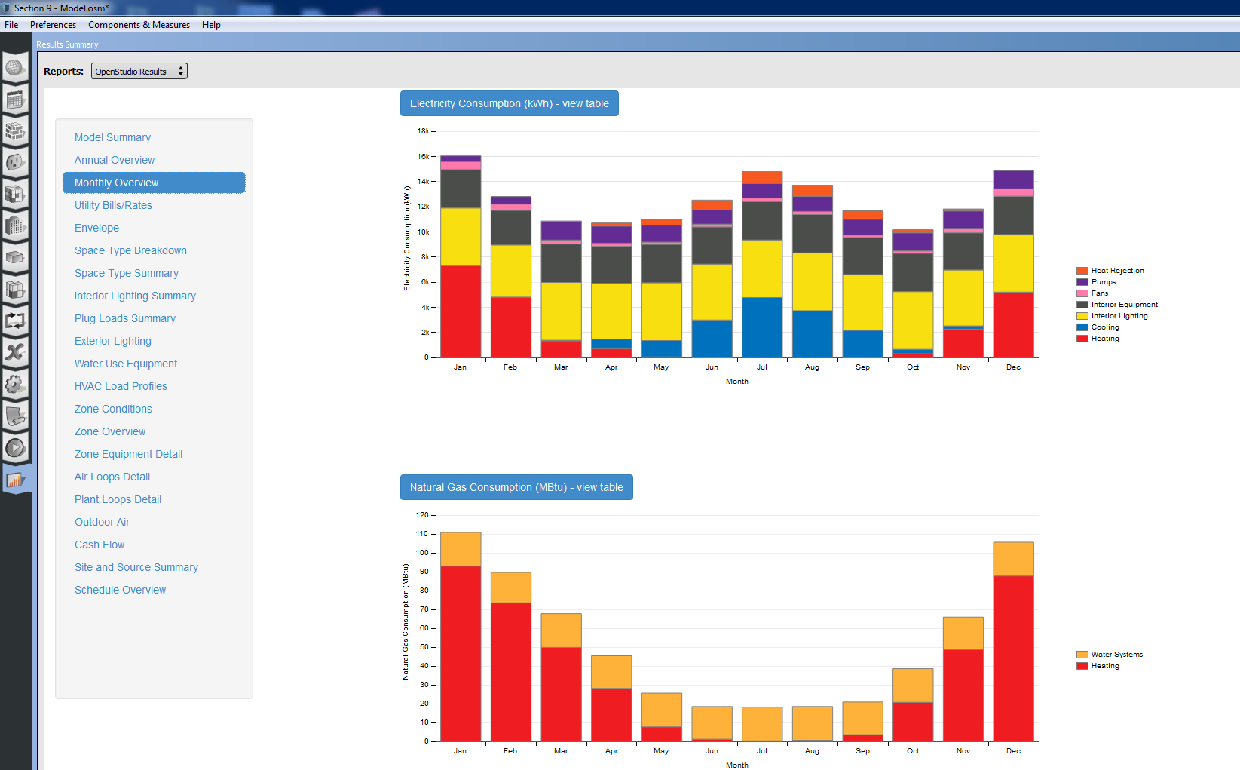

Figure .7 - Simulation results with service hot water

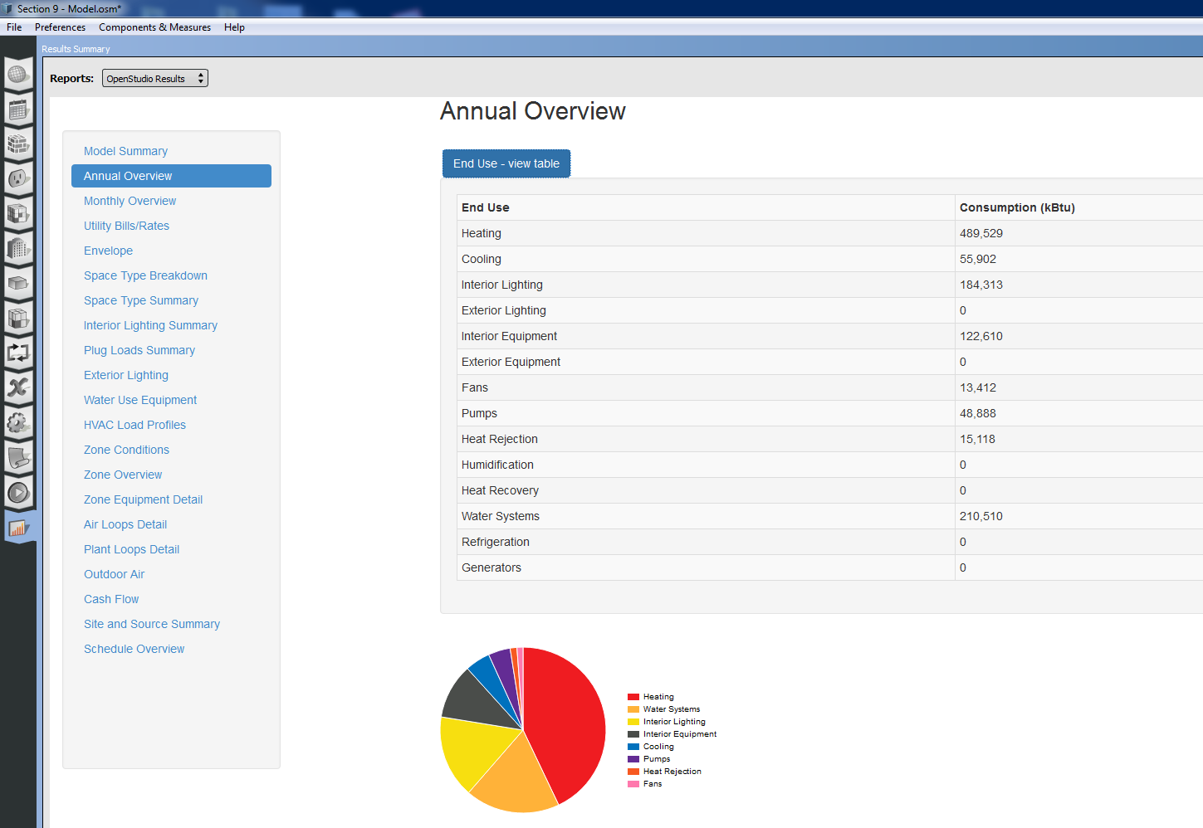

Figure .8 - Annual summary results with service hot water (EUI 114.03 kBtu/ft2)

# Advanced HVAC, Modeling a Dedicated Outdoor Air System

* 1. Create an Empty Air Loop.
     1. Go to the “HVAC System” tab and click the green “+”.
     2. Create an empty air loop.
  2. Add “Thermal Zone 5” the air loop.
     1. Drag “Thermal Zone 5” from “My Model” onto the demand side drop zone.
     2. Switch the “Library” click on the “Air Terminal Single Duct Uncontrolled” category.
     3. Drag the terminal onto the node just to the right of the “Thermal Zone 5” in the diagram.

Tip: Adding a thermal zone to an air loop will disconnect it from other air loops that it may have been on. It will not however remove zone equipment such as PTHP or PTAC systems.

* 1. Add outdoor air, cooling, heating, fan, and setpoint manager to the air loop.
     1. Go back to “Library” an “AirLoopHVAC Outdoor Air System” onto either of the two nodes in the supply half of the air loop.
     2. Repeat the last step, but add a “Coil Cooling Water” and make sure to use the node at the right side of the supply side of the loop.
     3. Add “Coil Heating Water” again to the right side node on the supply half of the loop.
     4. Add a “Fan Variable Volume” to the right side of the supply half of the loop.
     5. Lastly add a “Setpoint Manager Scheduled – Scheduled Deck Temp ” to the same right side node (Figure 10.1).

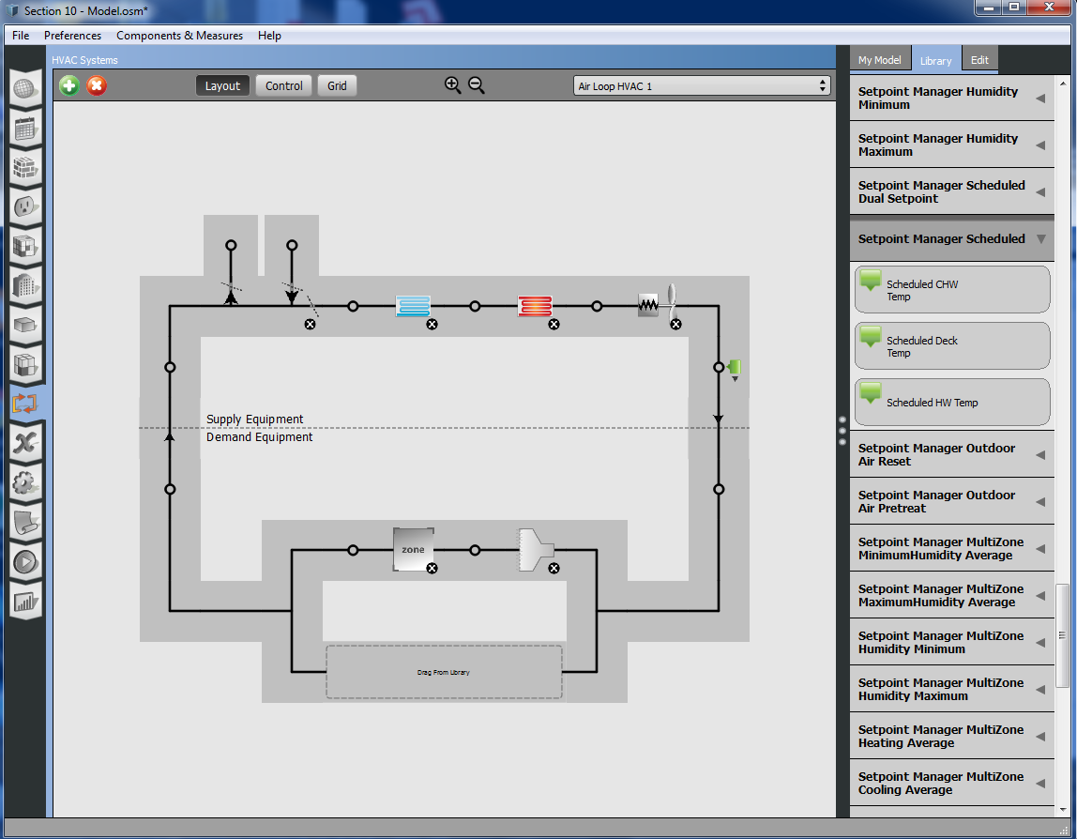

Figure .1 - Adding equipment to empty air loop

* 1. Link heating and cooling coils to plant loops.
     1. Select the coil cooling object and check the box for “Chilled Water Loop” (Figure 10.2).
     2. Select the coil heating object and check the box for “Hot Water Loop”.

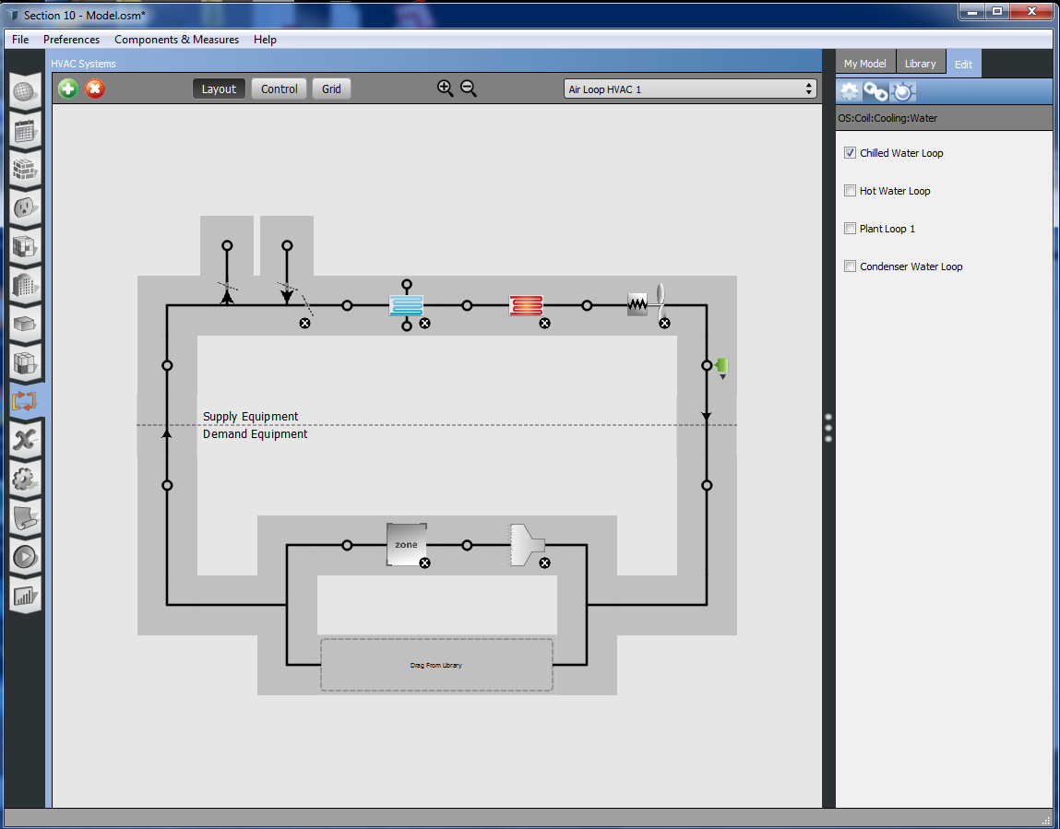

Figure .2 – Connecting water cooling coil to plant loop

Tip: If you want to rename the loops to have more meaningful names, click dotted line of your current loop to inspect the loop object and rename it.

* 1. Changes to the outdoor air objects
     1. Select the Outdoor Air System and set the “Minimum Fraction of Outdoor Air Schedule Name” to “Always On Discrete”. Make sure you are selecting the Outdoor Air object and not the inlet or outlet node (Figure 10.3).

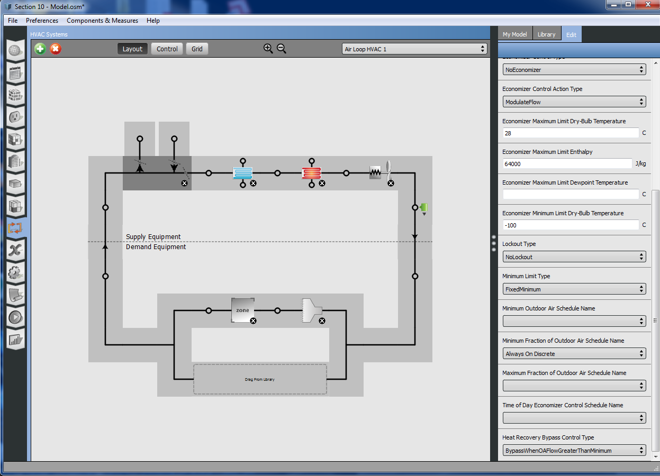

Figure .3 - DOAS outdoor air object

* 1. Change schedule on setpoint manager.
     1. Create the schedule needed for the setpoint manager.
        1. Switch to the “Schedules” main tab and then the “Schedules” sub-tab.
        2. Click the green “+” at the bottom left. When prompted by the dialog choose “Temperature” for the class and then click “Apply”.
           1. Leave the other fields as they are.
        3. After the schedule is made name it “Constant 20C”.
        4. The new schedule should show up at the top of the left side of the interface. Click on “Default” just below “Run Period Profiles.
        5. Hover over the blue horizontal line and set it to “20” Celcius.
     2. Go back to the “HVAC Systems” tab, “Air Loop HVAC 1” and select the scheduled setpoint manager.
     3. Set the “Schedule Name” field to “Constant 20C”.
  2. Changes to system sizing object.
     1. Select the dotted line between the supply and demand side to select the air loop and system sizing in the inspector (Figure 10.4).
     2. Change “Type of Load to Size On” to “VentilationRequirement”.
     3. Change “Minimum System Air Flow Ratio” to “1”.

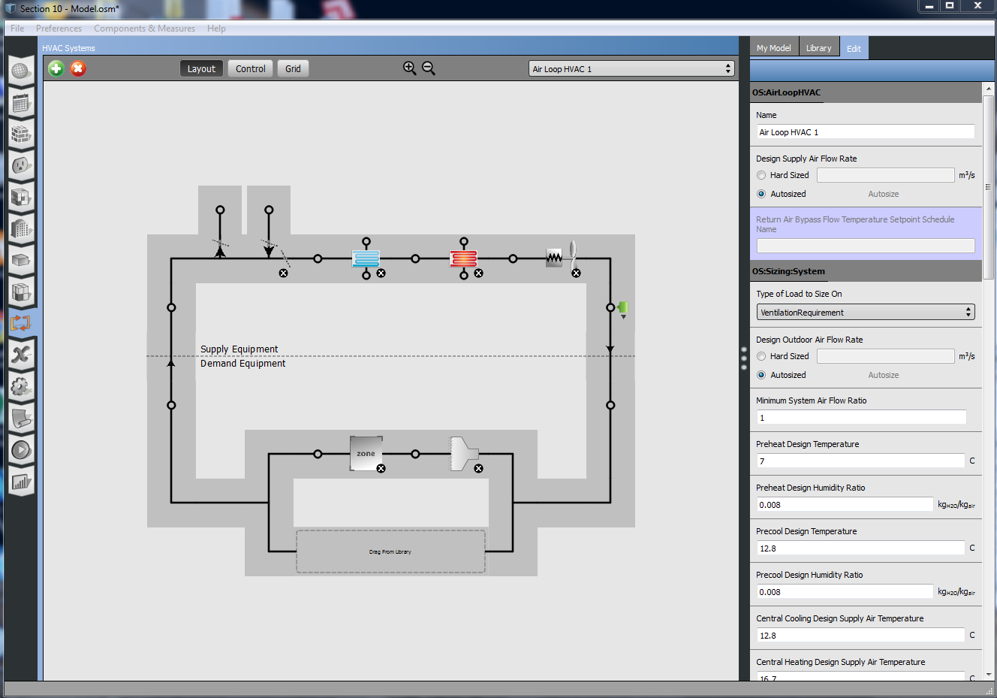

Figure .4 - Selecting an air loop

* 1. Add and edit PTHP object for “Thermal Zone 5” (Figure 10.5).
     1. Go to the the “Thermal Zone” tab.
     2. Drag a PTHP object from the “Library” to the “Zone Equipment” drop zone for ”Thermal Zone 5”.
     3. Select the PTHP object in “Thermal Zone 5” so you can inspect it in the right pane.
     4. Set the following objects to “Hard Sized” and then enter “0”.
        1. Supply Air Flow Rate When No Cooling or Heating is Needed
        2. Outdoor Air Flow Rate During Cooling Operation
        3. Outdoor Air Flow Rate During Heating Operation
        4. Outdoor Air Flow Rate When No Cooling or Heating is Needed

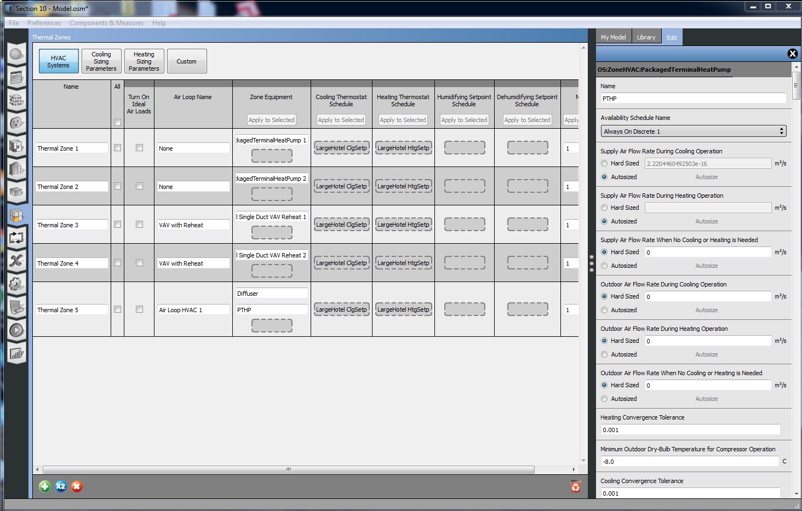

Figure .5 - Editing PTHP sizing fields

* 1. Save the model as “Section 10 - Model.osm” using “SaveAs” under the file menu.
  2. Optionally rerun the simulation. (Figure 10.6) (Figure 10.7).

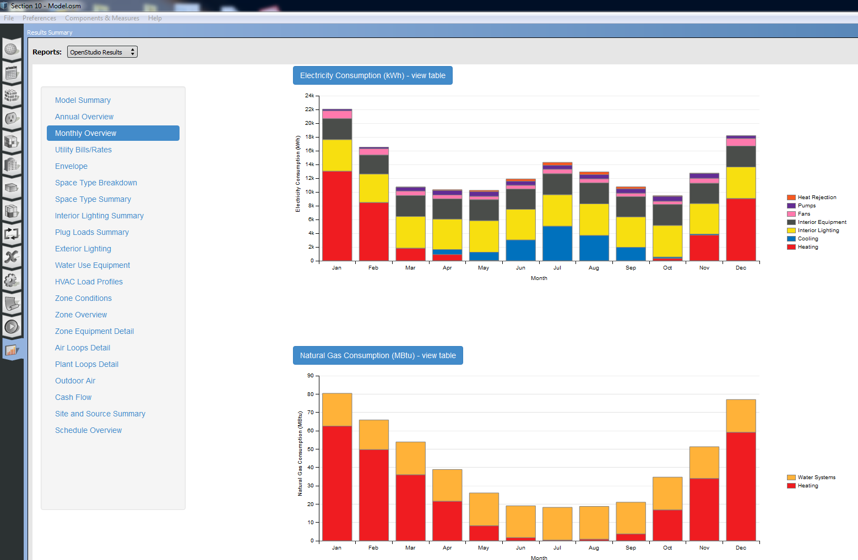

Figure .6 - Simulation results with a DOAS

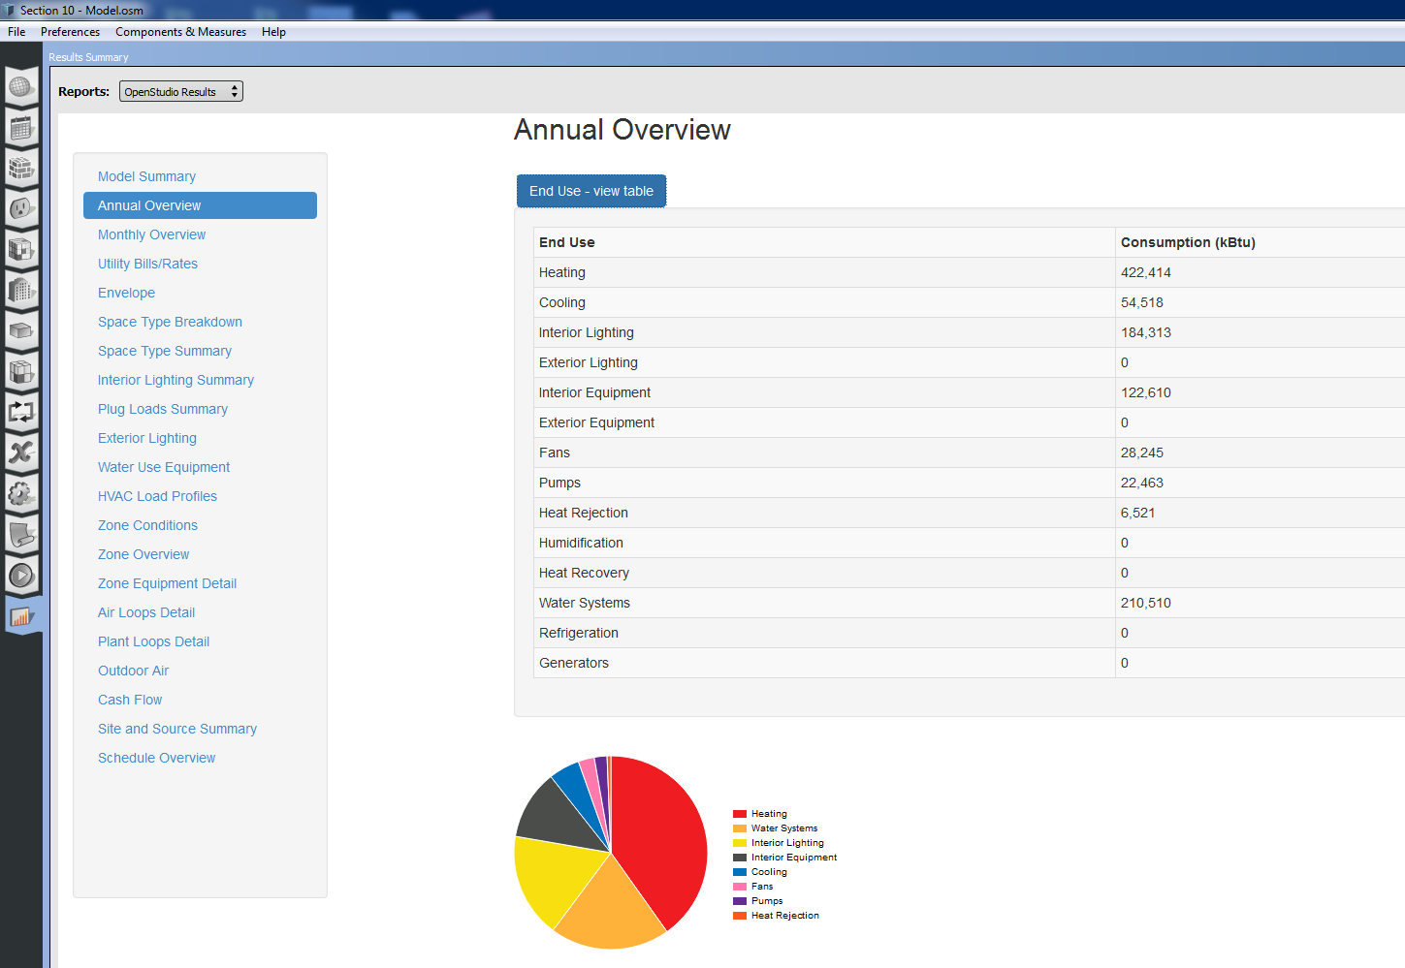

Figure .7 - Annual summary results with DOAS (EUI 105.16 kBtu/ft2)

# Support And Questions

* Use the OpenStudio E-mail or forum
  + <https://www.openstudio.net/forum>

Resources – YouTube Channel and Interactive PDF

* + <http://www.youtube.com/user/NRELOpenStudio>
  + http://nrel.github.io/OpenStudio-user-documentation/